Lab 3

Lab Section: Monday

October 25, 2020

Jonathan Nusantara, Eric Kahn, Eric Hall

jan265, edk52, ewh73

Introduction

The main objectives for lab 3 were to apply our knowledge of GPIO in a practical setting to create an embedded system. This meant using the concepts of input and output to take control commands from buttons, and relate that to outputs sent to the motor controller in order to spin our motors. In addition, the focus of this lab was on an embedded robot, meaning that it was capable of operating without any external monitor (only the PiTFT), keyboard or power cord plugged into the wall. Instead, the user interacts with the PiTFT and a GUI created using PyGame and the robot is powered by a battery pack velcroed to the bottom of the car. This means that the robot can move freely without hindrance. In addition, no external keyboard is needed because we included a call to our code in the .bashrc file, which executes on start-up. In order to control our motors, we output PWM signals with a specified duty cycle to control speed and two outputs per motor to control the direction of rotation.

Design and Testing

Week 1:

**Quick introduction to lab setup:**

Before starting the lab it would be great to get familiar with the components that will be used during the lab. In this first week, the two DC motors, a two-channel motor controller, and two LEDs will be used. The motor controller will be used to control each of the two motors (speed and direction), as well as redirect the right amount of voltage to the motors from the battery, instead of powering from the RPi (which will not be suitable). A diagram of the motor controller is as below:

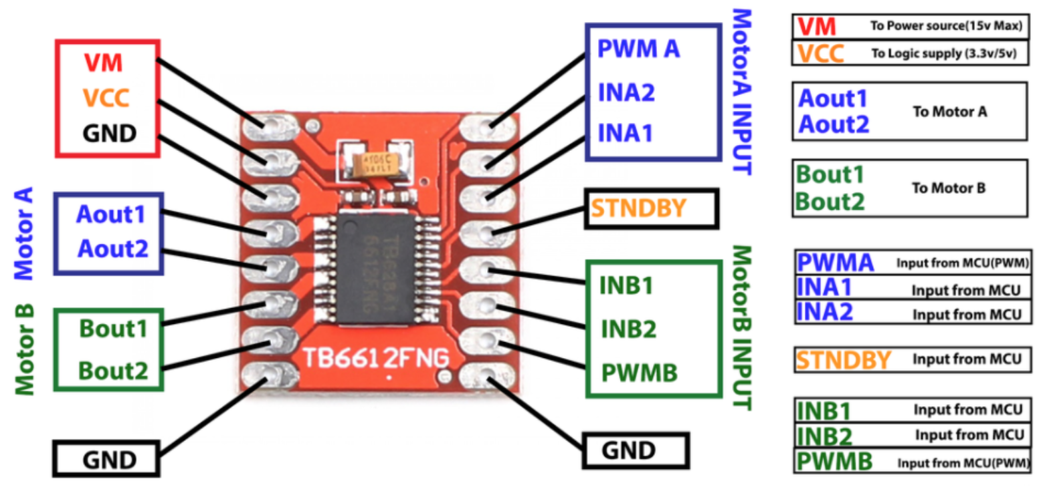

Figure 1 - A diagram showing the different pins on the motor controller.

The motor controller has 3 voltage-related pins. VM will be connected to the power source for the motor, which would be the batteries velcroed to the button of the car. VCC is connected to the 3.3V supply from the RPi. GND is the ground pin, which should be connected to a common ground from the RPi, battery, motor controller, and any other additional components used. The STBY pin means standby and should be connected to the VCC.

The rest of the pins are divided into motor A and B, and each would have 5 pins. The first two pins are out1 and out2, which are connected to the motor. The polarity of the motor does not matter to the pins, but may affect the direction control. In1 and In2 are the two pins that determine the direction of the motor, either clockwise or anti-clockwise. A table that explains the different settings of direction will be added below. The last pin is the PWM pin, which will be connected to the RPi GPIO that will output PWM signals. The duty cycle of the PWM signals will be used to adjust the speed of the motor (i.e if the duty cycle is 50% then it would produce about 50% of max speed).

Below is a table that describes the different modes of the motor when different control inputs are passed to the motor controller:

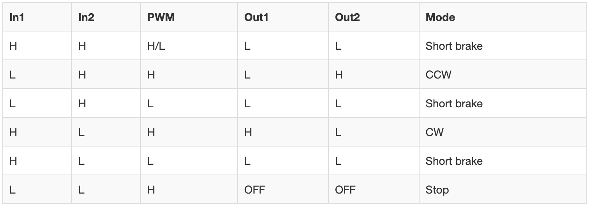

Figure 2 - Diagram showing the control inputs required for the different motor modes.

One important reminder is that each of the pins on the Raspberry Pi should be protected from bad voltages and currents. This can be done by using a resistor between the RPi pin with any other component. A good resistor to use is a 1k resistor, as it will limit the amount of current that may be passed to the RPi to an acceptable value. One should also be aware of the maximum current that can be drawn from the RPi. Lastly, one should also be careful about static shocks to any of the RPi pins.

Due to not having access to an oscilloscope, a program called piscope is used. From the /home directory, the following can be executed:

sudo pigpiod  
wget abyz.me.uk/rpi/pigpio/piscope.tar  
tar xvf piscope.tar  
cd PISCOPE  
make hf  
make install

There will exist a PISCOPE directory in /home and the script can be run using “./piscope”.

**PWM in RPi.GPIO:**

The RPi.GPIO library will be used to develop a program to control the motors. PWM, which stands for Pulse-Width Modulation, will be a huge part of the program. One should first familiarize with this topic first. Below are the basic GPIO functions that will be used for PWM:

p = GPIO.PWM(GPIO_pin, frequency)  
This command will declare a variable to be used to set PWM. The input to the function is the GPIO pin number and the frequency (in Hz).

p.start(dc)  
This function will start the PWM signal to be supplied from the pin. The duty cycle value is passed to this function and its range is 0 to 100 (based on a percentage duty cycle value).

p.ChangeFrequency(freq)  
The function above will be used to change the frequency of the PWM.

p.ChangeDutyCycle(dc)  
The function above will be used to change the duty cycle of the PWM.

p.stop()  
The function above will stop the PWM signal from being output from the GPIO pin. The PWM will also stop if the variable goes out of scope.

In order to familiarize with PWM, a simple blink.py program will be created. The goal is to create a program that will blink an LED on and off every second. The program should also be able to receive user input to change the frequency of the PWM. If we think about wanting to blink the LED every second, the frequency to use would be 1Hz, as one complete cycle would take 1 second. Then, if one second is to be divided equally between on and off, the duty cycle should be 50%.

The next step would be to set up the connections and the below diagram can be used as a reference:

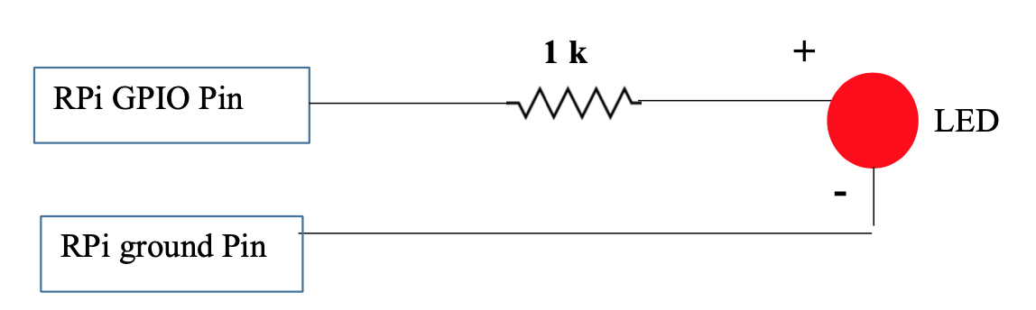

Figure 3 - Schematic diagram for LED connection to RPi.

The GPIO pin used will be of a personal choice, as long as they are not currently used by another system (i.e PiTFT). We have chosen to go with GPIO 26. The start of the program would be something that is always done and would be a good template. The program starts by importing the GPIO and time library. Next, the variable “start_time” is used to store the timestamp at the start of the program. Finally, the function “GPIO.setmode(GPIO.BCM) ”is declared to use the Broadcom numbering system.

Next, the main program is created as the code snipped below:

# Setup GPIO pin as output

GPIO.setup(26, GPIO.OUT) #PWMA

# Set variable as PWM

p = GPIO.PWM(26, 1) # Freq is 1Hz

p.start(50) # Set duty cycle to 50%

while (time.time()-start_time) < 10: # Set a timeout

user = input("Input a frequency: ")

p.ChangeFrequency(user) # Change frequency based on user input

p.stop()

GPIO.cleanup()

We start by setting GPIO pin 26 as an output as it will be used to output PWM signals. Then, variable “p” is declared as a variable for the PWM, and pin 26 is set as the pin for the PWM, which would have the frequency of 1 Hz. Then, PWM is started with a duty cycle of 50%. Based on our calculation, this should blink the LED every second.

A while loop that is limited to 10 seconds is used. In the while loop, a variable will use the “input()” function to try and get a float from the user. When a float variable is passed, that value will be used to change the frequency of the PWM using the “ChangeFrequency()” function.

At the end of the program after quitting the while loop (after running for more than 10 seconds), “p.stop()” is called to stop the PWM signal output and GPIO cleanup is performed to reset the GPIO for the next program to run. Remember that GPIO cleanup is extremely important, as unfortunate consequences may happen otherwise (i.e if a GPIO is set to output when it is receiving current from another component).

The final button setup should look something like this:

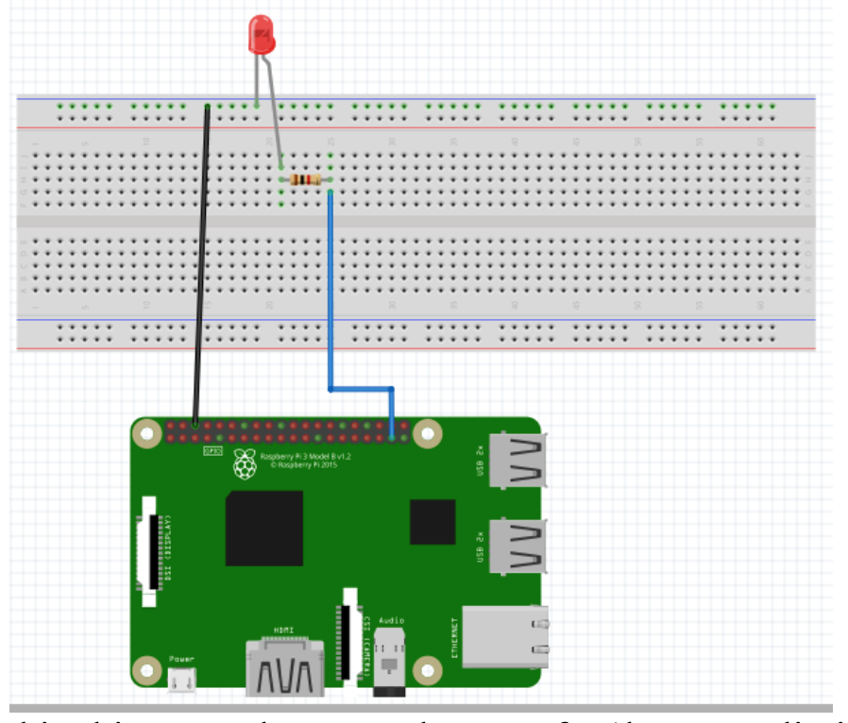

Figure 4 - Circuit setup of LED and RPi connection.

When testing the program, we observe that the LED will blink every second. If we pass a new frequency from the terminal, for example, a value of 2, then the LED will blink faster at every 0.5 seconds. When the frequency is even higher, our eyes cannot tell that the LED is blinking and it will look like it stays on. Piscope is also used to analyze the program and the result is as below:

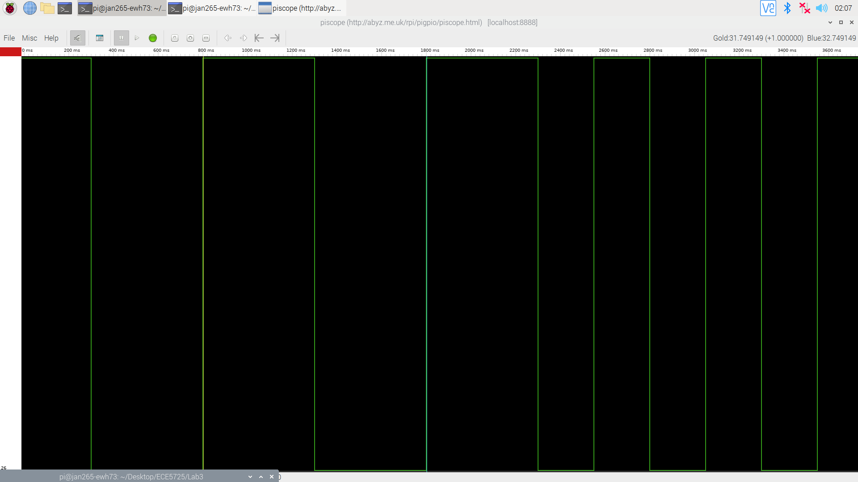

Figure 5 - Piscope result of blink.py with a frequency of 1Hz on the left and 2Hz on the right.

From the piscope result, we can see how the LED is blinking every second and having a 50% duty cycle on the cycles on the left. Notice the rising edge on 800ms and another rising edge on 1800ms, which means the LED blinks every second. Starting from around a little before 2600ms, the frequency was changed to 2Hz. This means that the LED blinks every half a second or two blinks a second. We can see from the plot how there are rising edges that has happened a little before the 3600ms mark on the timeline. We have confirmed that the program is running well. There are no major difficulties faced in this section.

**Running a single motor:**

In this section, we will try to run a single motor. This means that there are more components that need to be added to the breadboard. Please refer to the diagram below to have a better idea:

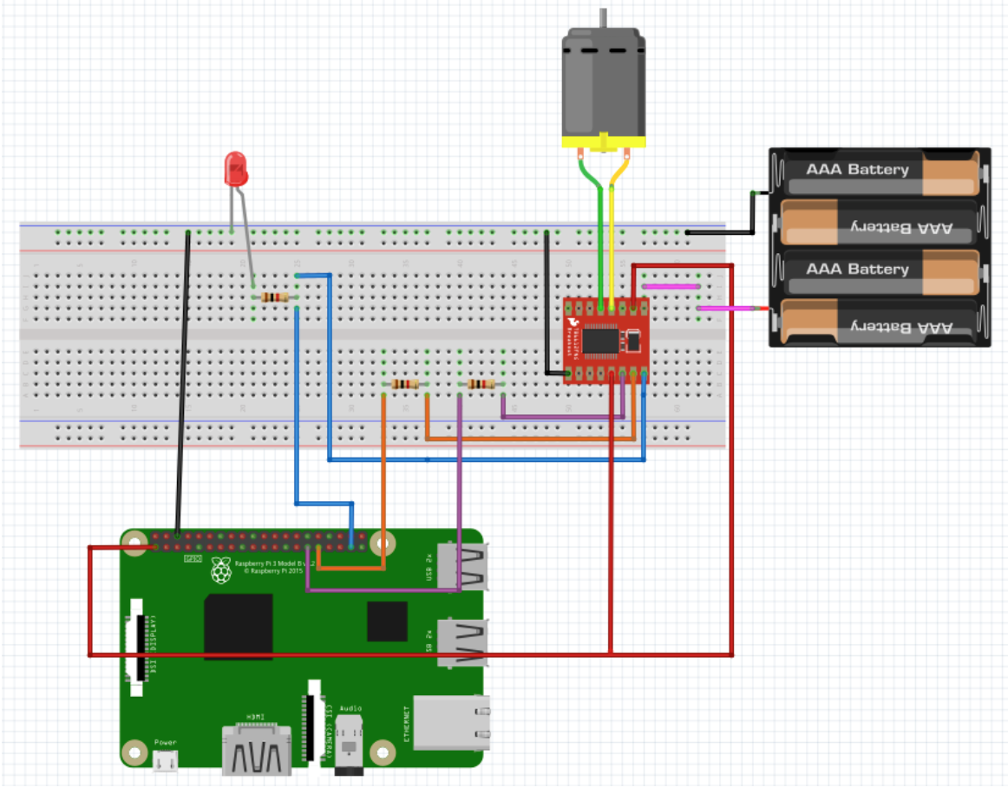

Figure 6 - Circuit diagram of a battery, LED, single motor and a motor controller connected to Raspberry Pi.

It would be difficult to tell what pins are connected to what components, so the goal of the diagram above is to give a brief overview. An important thing to notice is how each GPIO pin is first connected to a 1k resistor before being connected to another component to limit the current passed. Also, when you are reconnecting/building the circuit, remember to disconnect RPi from the power source and disconnect the battery from the circuit. Below is the list of things that need to be done:

1. Connect GPIO pin 5 and 6 to AIN1 and AIN2 on motor controller.
2. Connect GPIO 26 to PWMA on the motor controller. The connection to the LED may be kept, which will light up when motor is running.
3. Connect 3.3V from RPi to VCC and STBY on motor controller.
4. Connect 6V pin on battery pack to VM on motor controller.
5. Connect A01 and A01 pins on motor controller to the DC motor cables.
6. Connect all grounds from RPi, LED, motor controller, and battery to a single ground.

As mentioned before, make sure that the 1k resistor is in place in each pin connection. Once the connection is done, it is time to make the program.

The program should be named “motor_control.py”. There are several sequences of goals that need to be met:

1. Start the program by having the motor at a stop mode.
2. Run the motor to have 4 speeds in the clockwise direction: stop, slow, medium, and fast. The speed should be incremented every 3 seconds and a message should be displayed in the terminal for every increment.
3. Perform the same as above, but this time in the counterclockwise direction.
4. After the two types of loops, stop the motor and end the program.

Similar to the previous program, it starts with importing the GPIO and time library, declaring start_time variable and setting GPIO numbering to Broadcom. Next, the 3 GPIO pins should be set as below:

GPIO.setup(26, GPIO.OUT) #PWMA

GPIO.setup(5, GPIO.OUT) #AI1

GPIO.setup(6, GPIO.OUT) #AI2

All of the pins are set as output for their own purposes (PWM or AI).

Next, we need to think about what frequency and duty cycle value is needed. The frequency to use is 50Hz, as that is the PWM frequency that works well for motors. A “freq” variable is set to 50, and “dc” variable is set to 0 as the program should start with 0 speed or stop. But since an iteration needs to be implemented to cycle through the speeds, a list is created containing the various duty cycles. The four values are 0, 25, 50, 100, which would correspond to the 25% as slow, 50% as medium, and 100% as fast speed. As discussed at the beginning of the report, the duty cycle corresponds to the motor speed.

The next part of the program goes to the main PWM settings, where the motor control is happening. A code snippet is provided for visualization:

p = GPIO.PWM(26, freq)

GPIO.output(5, 0) # Set AI1 to low

GPIO.output(6, 0) # Set AI2 to low

p.start(dc) # Start with dc = 0

GPIO.output(5, 1) # Set AI1 to high

for i in dc_list:

print("dc = " + str(i))

p.ChangeDutyCycle(i)

time.sleep(3)

GPIO.output(5, 0) # Set AI1 to low

GPIO.output(6, 1) # Set AI2 to high

for i in dc_list:

print("dc = " + str(i))

p.ChangeDutyCycle(i)

time.sleep(3)

p.ChangeDutyCycle(0)

The variable “p” is first set up as the PWM variable, which would control GPIO 26 and has a frequency of 50Hz. GPIO 5 and 6 is initially set to low, which means that the motor will stop. Then, PWM is started using “start()” function, with the duty cycle of 0. Then, since we wanted to perform a clockwise direction, according to Figure 2, AIN1 should be high and AIN2 should be low. The corresponding GPIO output value is set. Then we iterate through the duty cycle list that was created, where in each value a message is printed in the console indicating direction and speed, the “ChangeDutyCycle()” function is called to change to the current duty cycle in the list, and a “time.sleep()” function is called to sleep for 3 seconds (thus running for 3 seconds).

Now that we have accomplished the clockwise direction, it is time to perform the counterclockwise direction. The output value on GPIO 5 and 6 is flipped and the same iteration is performed. In the end, the duty cycle is set to 0 to stop the motor from running. With the program being done, it ends with GPIO cleanup and the PWM stop function.

The program is then tested and it is running as expected. Below is the list of sequence that happened:

1. In clockwise direction, the frequency is 50Hz, Pulse Width is 0, and Duty Cycle is 0%. It ran for 3 seconds.
2. In clockwise direction, the frequency is 50Hz, Pulse Width is 0.005s, and Duty Cycle is 25%. It ran for 3 seconds.
3. In clockwise direction, the frequency is 50Hz, Pulse Width is 0.01s, and Duty Cycle is 50%. It ran for 3 seconds.
4. In clockwise direction, the frequency is 50Hz, Pulse Width is 0.02s, and Duty Cycle is 100%. It ran for 3 seconds.
5. In counterclockwise direction, the frequency is 50Hz, Pulse Width is 0, and Duty Cycle is 0. It ran for 3 seconds.
6. In counterclockwise direction, the frequency is 50Hz, Pulse Width is 0.005s, and Duty Cycle is 25%. It ran for 3 seconds.
7. In counterclockwise direction, the frequency is 50Hz, Pulse Width is 0.01s, and Duty Cycle is 50%. It ran for 3 seconds.
8. In counterclockwise direction, the frequency is 50Hz, Pulse Width is 0.02s, and Duty Cycle is 100%. It ran for 3 seconds.

From the LED, we can also see how its brightness is changing as different duty cycles are used. Another observation is also done in using piscope. Several measurements are made to provide a visualization of what is happening to the changes in duty cycle. Firstly, the plot below shows when the motor is moving clockwise at 25% duty cycle. The results are as below:

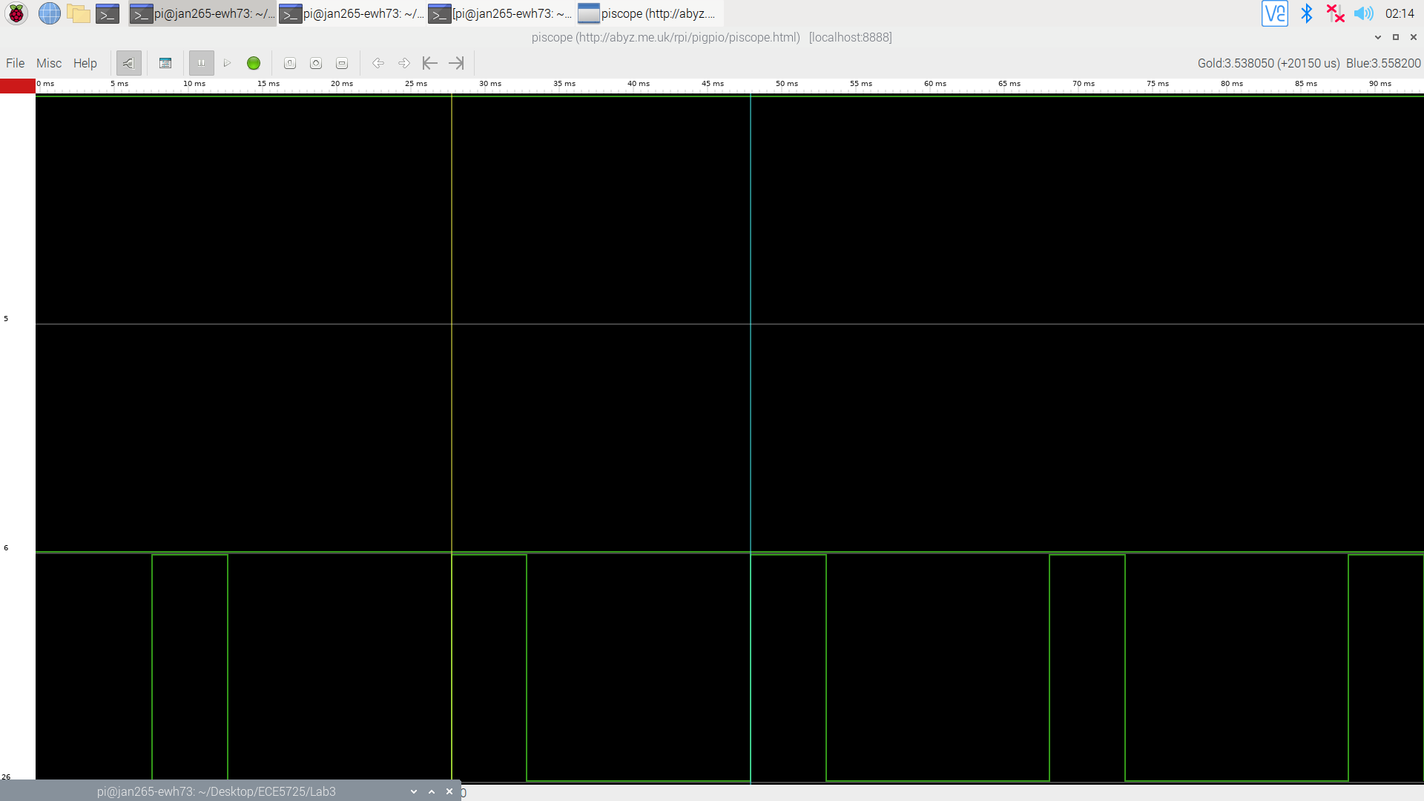

Figure 7 - Piscope of clockwise movement at 25% duty cycle.

On the left, you can see the labels of GPIO pins for the different rows of signal data. They are GPIO 5, 6, and 26 which are used for AIN1, AIN2, and PWM. In this example, since it is clockwise, we can see the GPIO 5 as always high and GPIO6 as always low, which is how the output should be set to have a clockwise movement. In the GPIO26, we can see how the duty cycle is 25%, which means that in each cycle 25% of it will be high. We can also see from the measurements recorded on the top-right corner that the period is about 20150us, which is around 0.02s. This relates to the 50Hz that we use, which will have a period of 0.02s. In the next two figures, the duty cycle of 50% and 100% will be displayed for clockwise movement:

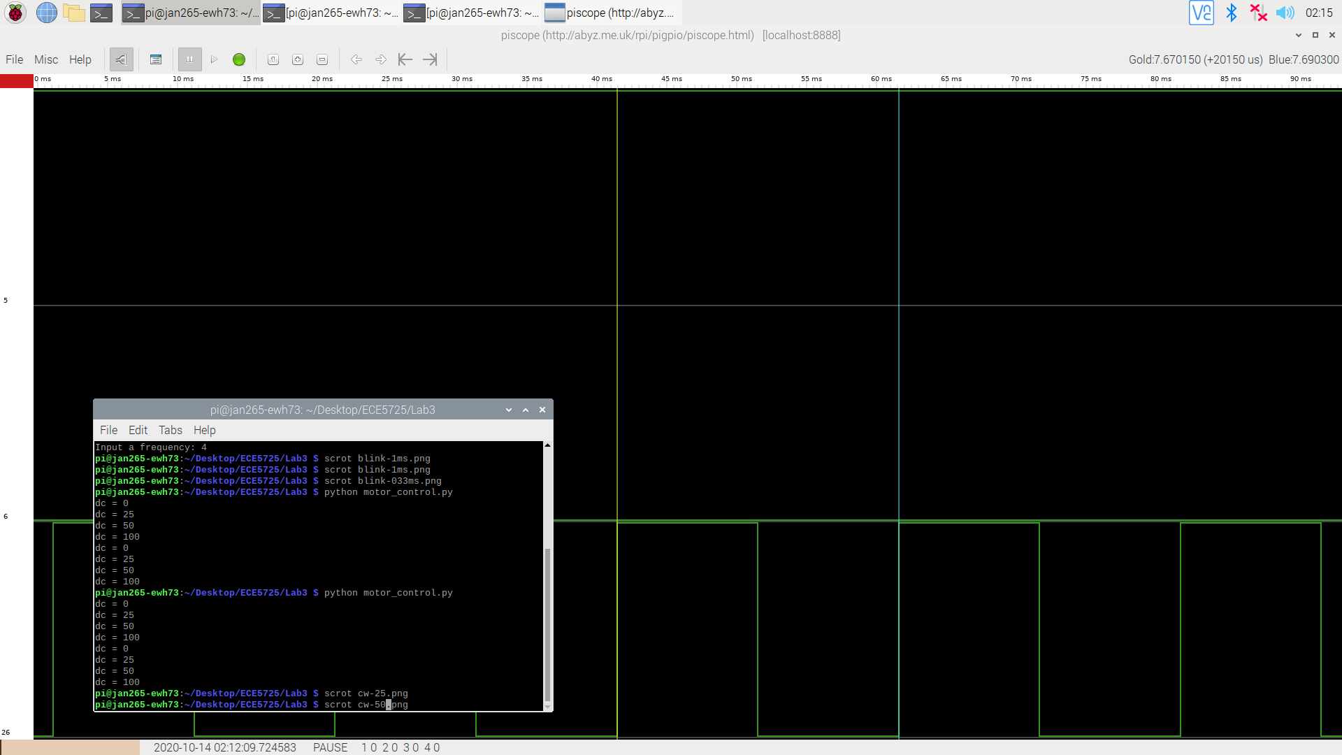

Figure 8 - Piscope of clockwise movement at 50% duty cycle.

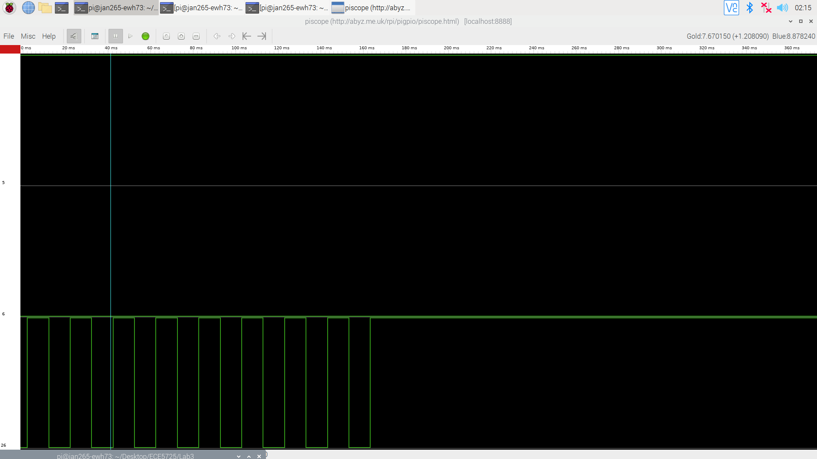

Figure 9 - Piscope of clockwise movement at 100% duty cycle.

From the two figures above, we can see how the piscope is showing the duty cycle at 50% with 50% of the cycle being high in Figure 8 and how 100% duty cycle is like in Figure 9.

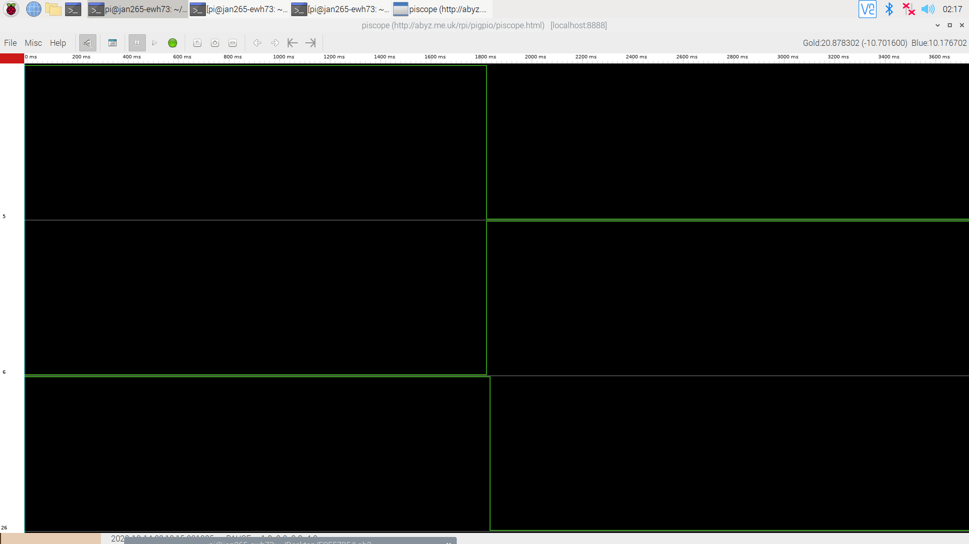

Figure 10 - Piscope of clockwise movement at 100% duty cycle

In the plot above, we can see the transition of a clockwise 100% duty cycle motor movement to a counterclockwise 0% duty cycle motor movement. We can see the switching of values in GPIO 5 and 6, where GPIO5 is now low and GPIO6 is now high to have the motor move counterclockwise. We can also see how GPIO26 became low.

Next, we will see the three plots of counterclockwise movement of the motor through different duty cycles:

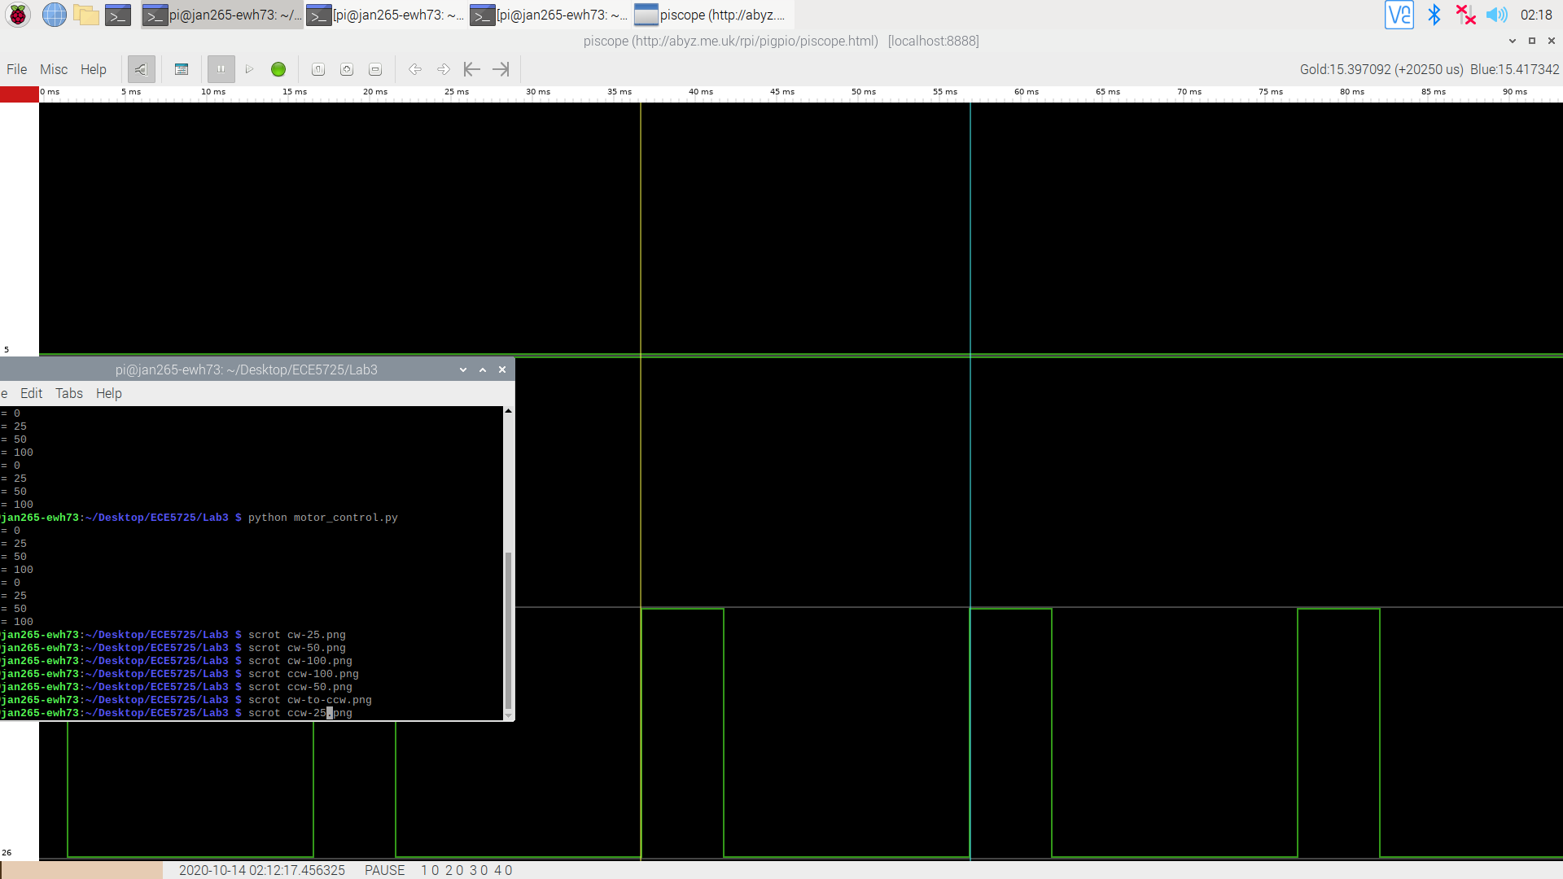

Figure 11 - Piscope of counterclockwise movement at 25% duty cycle

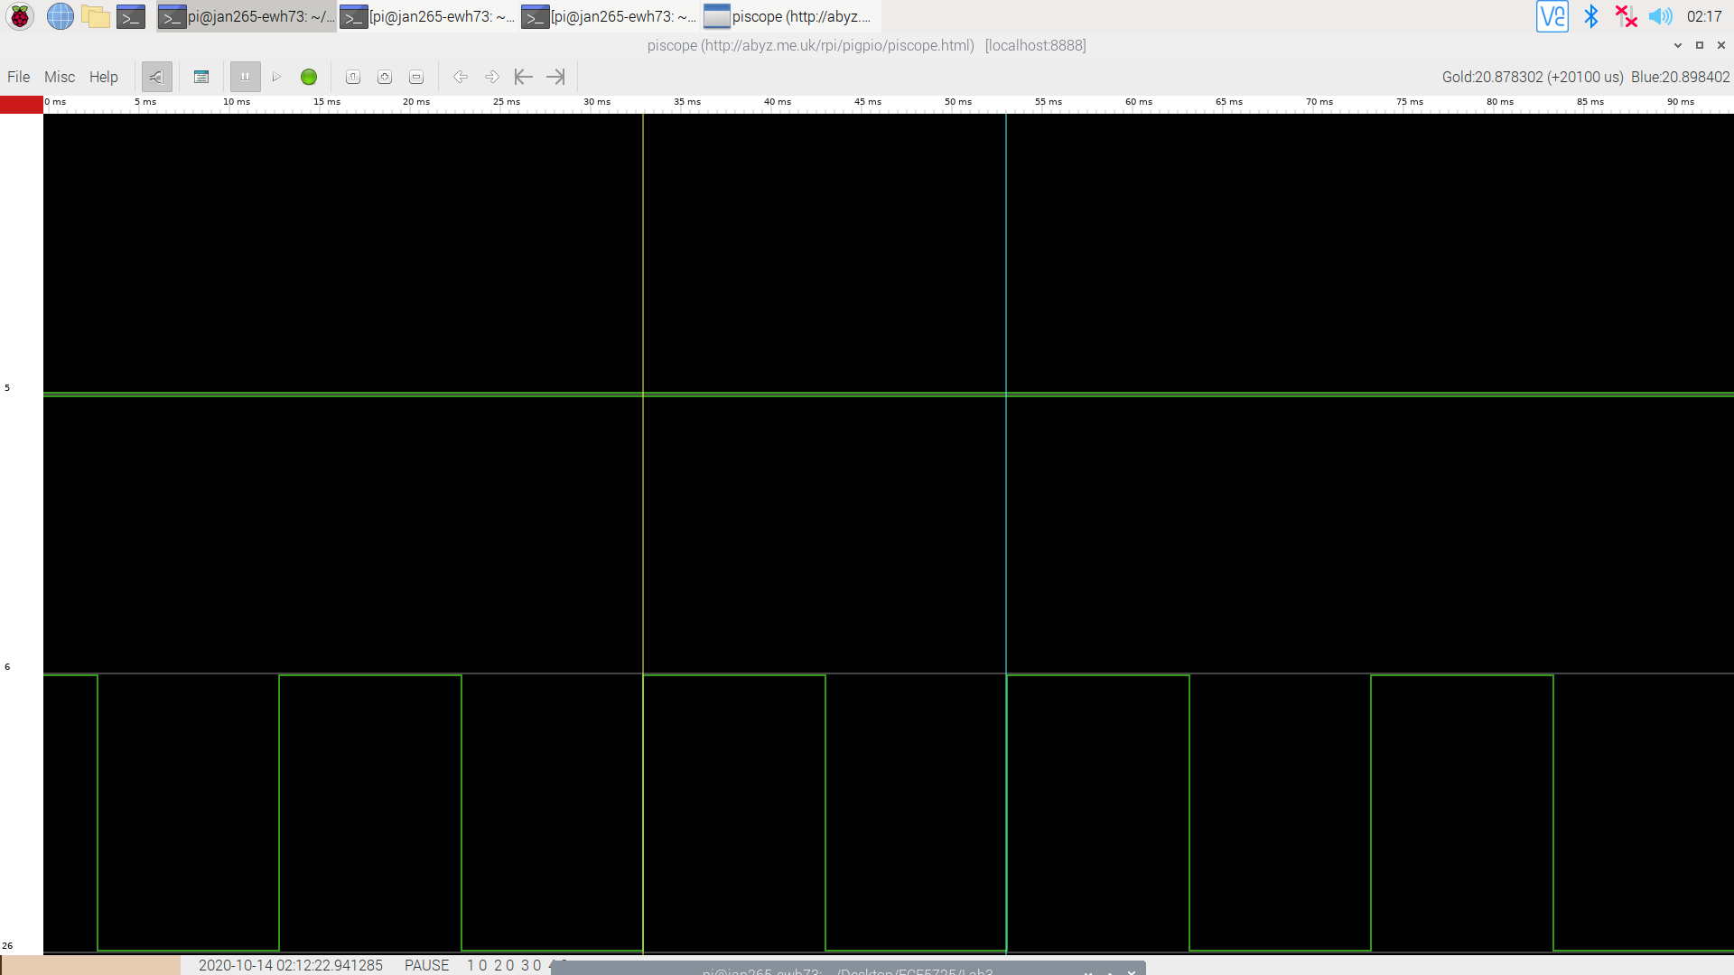

Figure 12 - Piscope of counterclockwise movement at 50% duty cycle

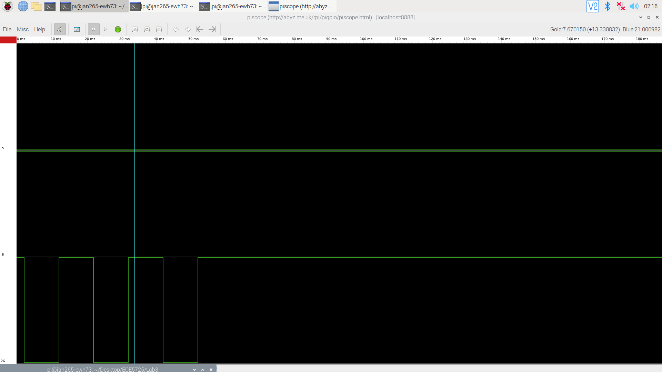

Figure 13 - Piscope of counterclockwise movement at 100% duty cycle

From Figure 11 to 13, we have seen the plot of motor’s counterclockwise movement with duty cycles of 25%, 50% and 100%. The PWM signal behavior will be similar to when it is moving in the clockwise direction. The difference is in the GPIO5 and values, where their values are now switched.

In this section, we are able to explore how to start the motor and to choose its speed and direction. There are no major difficulties faced. With this knowledge and experience, it would help us in integrating two motors to the system.

**Left and Right motors:**

Now that we have successfully worked with one motor, we will integrate the other motor to the system. The goal of this section is to have two motors: left and right, running together. Additionally, there should be a total of six motor functions that will run at full speed: stop, clockwise, and anti-clockwise for each left and right motor. Each of these functions can be called by using buttons and we plan to have a total of six buttons. This means that 2 additional external buttons will be added.

First, we will change the circuitry. This will involve adding several buttons, resistors and a motor to the circuit. Remember to disconnect RPi from the power source and disconnect the battery from the circuit before changing the circuitry. Also, be aware that for every GPIO pin connection below, a 1k resistor should be used between GPIO and the component. Below are the changes:

1. Connect GPIO pin 12 and 16 to BIN1 and BIN2 on the motor controller.
2. Connect GPIO 20 to PWMB on the motor controller. Create a similar connection to an LED like what has been done for the previous motor.
3. Connect A01 and A01 pins on the motor controller to the DC motor cables.
4. Connect two external buttons following the schematic diagram below, connecting to GPIO 4 and 13. Take note of the two resistors that are connected, as it serves as R1 serves as a pull-up resistor and R2 is used to limit current.

Above are all the changes that are needed for the circuit. The setup will now have a total of two motors, two LEDs, and six buttons (two external and four on PiTFT).

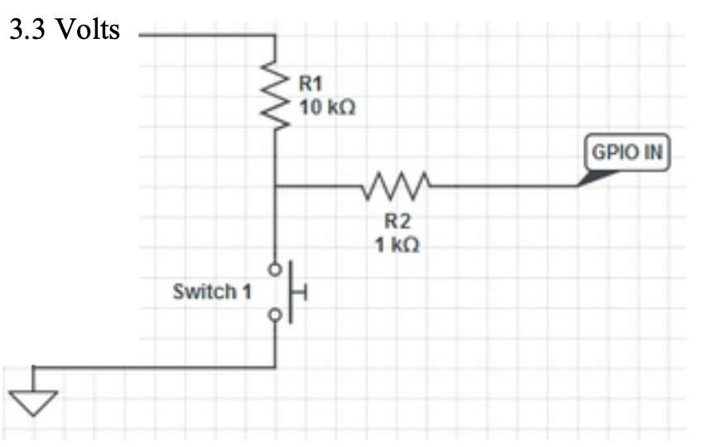

Figure 14- Schematic diagram for external button connection

Once all of the components have been connected together, it should look something like below:

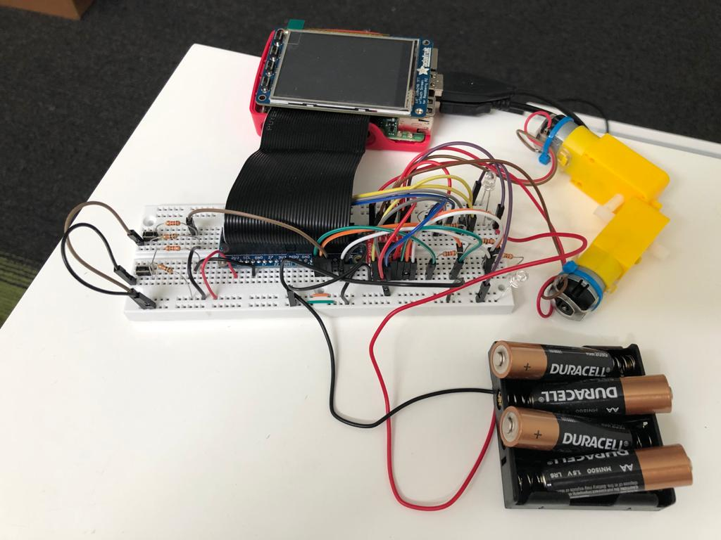

Figure 15 - Final circuit setup that connects two motors, motor controller, RPi, LEDs, and battery.

With the complete circuit ready, it is time to write the program “two_wheel.py”. This program should be built from “motor_control.py”, where it should start with importing the libraries, set up “start_time” variable, setting GPIO to Broadcom, and set up GPIO channels for motor A. Next, we will set up the GPIO outputs for motor B. Based on the GPIO chosen when building the circuit, the program will look like this:

GPIO.setup(20, GPIO.OUT) #PWMB

GPIO.setup(12, GPIO.OUT) #BI1

GPIO.setup(16, GPIO.OUT) #BI2

In total, we have six GPIOs used as outputs for the two motors. Next, we will set the GPIOs for the six buttons. Based on the choices of GPIOs for the two external buttons (4 and 13) and the four PiTFT buttons (17, 22, 23, 27), the program will look like this:

# PiTFT Buttons

GPIO.setup(17, GPIO.IN, pull_up_down=GPIO.PUD_UP)

GPIO.setup(22, GPIO.IN, pull_up_down=GPIO.PUD_UP)

GPIO.setup(23, GPIO.IN, pull_up_down=GPIO.PUD_UP)

GPIO.setup(27, GPIO.IN, pull_up_down=GPIO.PUD_UP)

# External buttons

GPIO.setup(4, GPIO.IN, pull_up_down=GPIO.PUD_UP)

GPIO.setup(13, GPIO.IN, pull_up_down=GPIO.PUD_UP)

All the GPIO required has now been set correctly.

Next, we will design our function definition to provide each motor for the capability to go clockwise, counterclockwise, or to stop. This function should have two parameters: motor number and direction. We will represent each parameter with integers. For motor numbering, we will treat “1” as left motor and “2” as right motor. For direction, we will treat “0” as stop, “1” as clockwise, and “2” as counterclockwise. Based on Figure 2 and “motor_control.py”, we have also learned the required settings for IN1 and IN2 for different motor modes. A summary is as below:

* Both IN1 and IN2 low means to stop
* IN1 high and IN2 low means clockwise
* IN1 low and IN2 high means counterclockwise

Based on the required settings, the function definition called “control()” is written as below:

def control(motor_num, direction):

if motor_num == 1: # left

if direction == 0: # stop

GPIO.output(5, 0) # Set AI1 to low

GPIO.output(6, 0) # Set AI2 to low

elif direction == 1: # cw

GPIO.output(5, 1) # Set AI1 to high

GPIO.output(6, 0) # Set AI2 to low

elif direction == 2: # ccw

GPIO.output(5, 0) # Set AI1 to low

GPIO.output(6, 1) # Set AI2 to high

elif motor_num == 2: # right

if direction == 0: # stop

GPIO.output(12, 0) # Set BI1 to low

GPIO.output(16, 0) # Set BI2 to low

elif direction == 1: # cw

GPIO.output(12, 1) # Set BI1 to high

GPIO.output(16, 0) # Set BI2 to low

elif direction == 2: # ccw

GPIO.output(12, 0) # Set BI1 to low

GPIO.output(16, 1) # Set BI2 to high

This program will have if conditional statements to check for the motor number and direction passed as inputs. Based on the inputs, it will set the corresponding IN1 and IN2 GPIOs for either motor A or B based on the wanted outcome. For example, if “motor_num” is set to 2 and “direction” is set to 2, this means that the function should move the right motor in a counterclockwise direction. Based on the program above, GPIO12 will be set to low and GPIO16 will be set to high.

Then, we will set up a few required initializations. Firstly, the a frequency variable should be set to 50Hz, as it is the recommended working frequency for DC motors:

freq = 50 # Initial frequency

Two variables should also be set for the two PWMs of the motors. The corresponding GPIO will be passed along with the frequency of 50Hz:

p = GPIO.PWM(26, freq)

p2 = GPIO.PWM(20, freq)

Then, since the program should start with both motors not moving, let us reset each of the motors IN1 and IN2 to be low by setting the corresponding output GPIOs:

GPIO.output(5, 0) # Set AI1 to low

GPIO.output(6, 0) # Set AI2 to low

GPIO.output(12, 0) # Set BI1 to low

GPIO.output(16, 0) # Set BI2 to low

Once all set up is ready, we can start the PWM signals. Since we desire our motor to run at full speed, this means that the duty cycle of the PWM should be 100%. So the PWM is started with 100% duty cycle:

p.start(100) # Start with dc = 100

p2.start(100) # Start with dc = 100

Now, it is time to design how the buttons should be able to call each of the functions written above to control the direction of each motor. We have learned that using a callback interrupt is much more efficient compared to a polling loop, so we will go with it. Each button will be used to call one type of mode (motor number and direction). Firstly, we will be choosing which buttons will be used for what motor modes. Below is the breakdown:

|  |  |  |
| --- | --- | --- |
| GPIO number | Motor mode | Function parameters |
| 17 | Right motor, cw | control(2,1) |
| 22 | Right motor, ccw | control(2,2) |
| 23 | Left motor, cw | control(1,1) |
| 27 | Left motor, ccw | control(1,2) |
| 4 | Right motor, stop | control(2,0) |
| 13 | Left motor, stop | control(1,0) |

Now that we have broken down the purposes of each button, it will be much simpler to program. A total of 6 GPIO callback functions will be written. Inside each of the functions, the “control()” function will be called with the input parameters as above to achieve the desired motor mode. Below is a code snippet of how it was done for GPIO 17 and 22:

def GPIO17_callback(channel):

print("right motor, clockwise")

control(2, 1)

def GPIO22_callback(channel):

print("right motor, ccw")

control(2, 2)

Similar to the above callback examples for GPIO 17 and 22, callback functions are also written for the four other button GPIOs.

Now that we have the callback ready, we will need an event detection to detect button presses. We would want the program to detect when a button is on the falling edge, since the button is set to have a pull-up resistor. It should also be able to counter the mechanical bouncing problem. Below is the code written:

GPIO.add_event_detect(17, GPIO.FALLING, callback = GPIO17_callback, bouncetime = 300)

GPIO.add_event_detect(22, GPIO.FALLING, callback = GPIO22_callback, bouncetime = 300)

GPIO.add_event_detect(23, GPIO.FALLING, callback = GPIO23_callback, bouncetime = 300)

GPIO.add_event_detect(27, GPIO.FALLING, callback = GPIO27_callback, bouncetime = 300)

GPIO.add_event_detect(4, GPIO.FALLING, callback = GPIO4_callback, bouncetime = 300)

GPIO.add_event_detect(13, GPIO.FALLING, callback = GPIO13_callback, bouncetime = 300)

For each button’s GPIO, an event detection is created. It will call the corresponding callback functions, which would then execute the “control()” function to run the motors. It also has a bouncetime of 300, which translates to 300ms, to prevent button bouncing and unwanted button presses.

Button presses will now be detected, which will then trigger the desired movements on the motors. Finally, a simple while loop is designed to keep the program running until the desired timeout.

code_run = True

while code_run: # Infinite while loop

if (time.time() - start_time) > 60:

code_run = False

This program simply means that the while loop will continue to run until it has run for 60 seconds. As long as the while loop is running, the program will detect for button presses, which means that we can control the motors.

At the very end of the code, once it exits from the while loop due to the timeout, the following lines of code should be executed:

p.stop()

p2.stop()

GPIO.cleanup()

It is extremely important to stop the two PWM signals as we would not want the motor to keep on running even after the program has quit. We will also perform a GPIO cleanup to reset all of the GPIO settings.

The program is then tested and it is working as expected. Each of the buttons will perform the desired motor movement. Both motors are also able to run together. There are no major challenges faced and this section is able to be completed smoothly. A lot of time is taken in building the circuit as there are a lot of connections to be made. This section simulates on how two motors can be running together. Creating a function to help control motor modes is also very beneficial and can be used for more complex systems, such as when we will be running the wheels of the robot.

To increase the portability of this code, Eric took the control() method and setup, and wrapped it in a MotorController class. Instead of setting up each motor and the enable output in the main python script, the MotorController constructor handles it. Then, each motor can be set independently, or together via a TankDrive method. This provides some more functionality, especially the ability to easily disable and reenable the motor controller from the Pi, the ability to set motor speeds as a percent (and infer direction from that percent), the ability to choose between “braking” motors (internal short of the motor leads) when the speed is 0 or instead letting them “coast” (high impedance connection to the motor leads), and the ability to easily in software reverse output polarity without having to touch the circuitry again -- so positive percents can always be forwards.

At the end, a backup is made for the microSD card of the RPi, which will allow us to restore this backup if anything happens.

**Rolling Control:**

From last week’s lab, we are able to control both motors by pressing one of the six buttons to input motor commands, where we will be choosing the motor that we are controlling and the direction that the motor will run (or to stop). Now, we will be combining the features of moving the motors with buttons with some displays and interactions in PiTFT.

In PiTFT, there will be some information displayed and touchscreen buttons for inputs. There will be a left and right history log and each of it will display the last three motor commands passed to the corresponding motor, as well as the time (in seconds) that it was called since the program has started. The latest motor commands passed will be at the top of the log. Next, there will be a circle red “STOP” button. When this button is pressed, the motor will stop all motors and this button will change into a green “RESUME” button. None of the buttons will work when we are in the stop state. When the “RESUME” button is pressed, the motor will not move right away for safety reasons, but will now accept the button inputs for motor movements. Lastly, there will be a “QUIT” button on the PiTFT, which will quit the program when it is pressed.

The program that will be written is “rolling_control.py” and it will be based on the previous program “two_wheels.py”. We will be adopting the GPIO settings, motor command functions, and button interrupt callbacks that are created in “two_wheels.py”.

We open the program by importing the required libraries. There are additional libraries that need to be imported when compared to “two_wheels.py”, such as pygame and subprocess. The full library list imported is as below:

import RPi.GPIO as GPIO

import time

import sys

import pygame

from pygame.locals import*

import os

import subprocess

Then, a ”start_time” variable is created to save the time in which the program starts.

Additionally, since we will be using PiTFT and interacting with the touchscreen, several environments need to be set. Below is the code that will set the required drivers for the display and mouse or touchscreen:

os.putenv('SDL_VIDEODRIVER', 'fbcon')

os.putenv('SDL_FBDEV', '/dev/fb1') # Display on PiTFT

os.putenv('SDL_MOUSEDRV', 'TSLIB')

os.putenv('SDL_MOUSEDEV', '/dev/input/touchscreen')

Next, the GPIO channels setup are made identical to how it was discussed in the previous section in “two_wheels.py”, such as setting in Broadcom numbering system, adding a total of 6 GPIOs as inputs for buttons and 6 GPIOs as outputs for motor control.

Since we are now using pygame, there are some initializations that need to be performed. Firstly, pygame is initialized by this line:

pygame.init()

Then, several initializations are made which involves making the mouse cursor invisible and creating variables of screen/surface size and constant color variables. These variables will be used for button or font colors. The code is as below:

pygame.mouse.set_visible(False)

size = width, height = 320, 240

WHITE = 255, 255, 255

BLACK = 0, 0, 0

RED = 255, 0, 0

GREEN = 0, 255, 0

Now that initializations have been made, the surface will be created and it will have a black background:

screen = pygame.display.set_mode(size)

screen.fill(BLACK)

In this program, there will be buttons and text displayed in the PiTFT. So, fonts and buttons need to be initialized. The code is as below:

my_font = pygame.font.Font(None, 20)

my_buttons = {'STOP':(160, 120), 'RESUME':(160, 120), 'Left History':(60,20), 'Right History':(250,20), 'QUIT':(220,200)} # Make quit button

A variable for font is created and the font is set to have the size of 20. For the buttons, a dictionary is created. In each entry, the key will be the name of the button that will be displayed, while the value will be the x-y coordinates of the screen where the buttons will be displayed. These coordinates are not guesses, but have been experimented with to be positioned to provide the best visual display on the PiTFT for user interactions.

In this program, there will also be a history log for both left and right motors that will store the last three motor commands on each side. The entries will be stored in a list, which will be used like a queue that has a First In First Out. The code that prepares the list is as below:

# Create queue from list for motor control log

left_log = []

right_log = []

# Append logs with default content of Stop

for i in range(3):

left_log.append(("Stop", 0))

right_log.append(("Stop", 0))

# Setup coordinates for each log content

left_log_coordinate = [(60, 110), (60, 80), (60, 50)]

right_log_coordinate = [(250, 110), (250, 80), (250, 50)]

In the beginning, a list is created for each side of the motor log. In each of the list, it will store the entries of the motor command along with triggered time, which will be a list on its own. As a result, this list will be a 2-D list. Next, we will first append the list with another list where its index 0 is the motor state “Stop” and the index 1 will be the time where this command is called. Each side of the log is appended with this entry three times, just as a default display when the log is displayed on the PiTFT later. Finally, the coordinates for each of the log entries need to be set. This was done by creating a list of x-y coordinates. Notice how the list coordinates start with a bigger y value. This is because the entry in the index 0 of the log will actually be the earliest entry (which would be the next to be removed from the list), and we would want this entry to be located at the bottom of the list.

Next, the function definition for the motor control is written. This function is almost identical to the function in “two_wheels.py”, with an addition of an if condition and that it will now append entries to the log based on the corresponding motor control called. Below is a code snippet for the first half of the function, which displays the code for the left motor:

def control(motor_num, direction):

if stop == False: # Only change motor mode if not in stop state

if motor_num == 1: # left

if direction == 0: # stop

GPIO.output(5, 0) # Set AI1 to low

GPIO.output(6, 0) # Set AI2 to low

left_log.pop(0) # Remove first index

left_log.append(("Stop", int(time.time() -

start_time)))

elif direction == 1: # cw

GPIO.output(5, 1) # Set AI1 to high

GPIO.output(6, 0) # Set AI2 to low

left_log.pop(0)

left_log.append(("Clkwise", int(time.time() -

start_time)))

elif direction == 2: # ccw

GPIO.output(5, 0) # Set AI1 to low

GPIO.output(6, 1) # Set AI2 to high

left_log.pop(0)

left_log.append(("Counter-Clk", int(time.time() -

start_time)))

At the beginning of the function, there is an if condition that checks if “stop == False”. This “stop” variable is created to see if the current program state is at stop. This means that the red “STOP” button has been pressed and the button motor control input will not be functional. So, the code in the function will only be executed if we are not in the “STOP” state. Another difference that this function has is in each motor direction, it will now insert and remove an entry in the corresponding log. So in the code above, we can see how “left_log.pop(0)” is performed, which means that the entry in index 0 in that list is removed. Then, a new one is inserted in index 2 using the append() function. The entry that is appended depends on the button that is pressed (stop, clockwise, or counterclockwise). The entry will have a time component, which is calculated using “int(time.time()-start_time”, where it will be the time since the program is started and rounded to an integer value.

Next, we will perform several initializations related to the motor. First is in setting a frequency variable, which is set to 50Hz as that is an ideal PWM frequency for DC motors. Then, the PWM variable is created for both motors to GPIO 26 and 20. Lastly, the direction control pins for each motor is set to 0. The code snippet is as below:

freq = 50 # Initial frequency

p = GPIO.PWM(26, freq)

p2 = GPIO.PWM(20, freq)

GPIO.output(5, 0) # Set AI1 to low

GPIO.output(6, 0) # Set AI2 to low

GPIO.output(12, 0) # Set BI1 to low

GPIO.output(16, 0) # Set BI2 to low

The next part of the code is in creating GPIO callbacks functions for the buttons and the event detection for the button presses. They are identical to the code in “two_wheels.py”, which has been discussed in the previous section. A snippet of the callback function and event detection for GPIO 17 is as below:

def GPIO17_callback(channel):

print("right motor, clockwise")

control(2, 1)

GPIO.add_event_detect(17, GPIO.FALLING, callback = GPIO17_callback, bouncetime = 300)

The callbacks and event detections are created for all GPIO for buttons.

Now that all of the initializations have been written, we will be discussing the main while loop. Right before that, some final initializations are made. Two variables are created: “code_run”, which is used for the while loop condition and is initialized as True, and the “stop” variable that is used to store on whether the program is in the “STOP” state, and is initialized to False. Lastly, the PWM for both motors are started by using the function start(), and setting the duty cycle as 75 as below:

p.start(75)

p2.start(75)

In the while loop, it starts with checking for touchscreen presses. For a better explanation, a code snippet is included:

for event in pygame.event.get():

if event.type == pygame.QUIT:

pygame.quit()

p.stop()

p2.stop()

GPIO.cleanup()

sys.exit()

if (event.type is MOUSEBUTTONDOWN):

pos = pygame.mouse.get_pos()

elif (event.type is MOUSEBUTTONUP):

pos = pygame.mouse.get_pos()

x,y = pos

if y > 90 and y < 150 and x > 130 and x < 190:

print("Stop button is pressed")

if stop == False:

# Stop both motors

control(1, 0)

control(2, 0)

stop = True

elif stop == True:

print("Resume button is pressed")

stop = False # Allow motor mode change

elif y > 180 and y < 220 and x > 200 and x < 240:

print("Quit button is pressed")

code_run = False # Quit the while loop

We will quit the program if a pygame.QUIT event is detected. Nothing major will also happen if the MOUSEBUTTONDOWN event is detected, which is when the touch actually happens (not when letting go). The majority of code design is done during MOUSEBUTTONUP, which is when you let go of the touch.

In this check for MOUSEBUTTONUP, we will be identifying whether the touch is on the buttons that were created. If they are, then the corresponding actions need to be taken. The x-y coordinates are recorded using “pygame.mouse.get_pos()” function. Then, we will first check if either the “STOP” or “RESUME” button is pressed (both are at the same location and only one of them will be displayed), which will be in the coordinate range: 90<y<150 and 130<x<190. If the “STOP” button is pressed (identified based on the “stop” variable that will be equal to False), then the control function will be called to stop both motors, and the “stop” variable will be set to True to stop button motor control. On the other hand, if the “RESUME” button is pressed, then the “stop” variable will be set to False and it will again allow buttons to input motor control.

Another button that we are checking is the “Quit” button, which is in the range of: 180<y<220 and 200<x<240. If it is pressed, then “code_run” will be set to False and the while loop will quit, which then leads to the program to quit.

Next, we will enter a stage where different components will be displayed in PiTFT. The screen is first cleared by using the fill() function and setting it to BLACK. Then, we will first display the motor control history log. The code snippet is as below:

for i in range(3): # Left

dir_motor = left_log[i][0]

time_motor = left_log[i][1]

msg = dir_motor + " " + str(time_motor) # message to be printed

text_surface_log = my_font.render(msg, True, WHITE)

rect_log = text_surface_log.get_rect(center= left_log_coordinate[i])

screen.blit(text_surface_log, rect_log)

A for loop of range of 3 will be utilized, which will perform this loop for each index in the log list created in the beginning of the program. In each index, the value of the motor direction and the time it was triggered is first stored into the two variables “dir_motor” and “time_motor”. Then, a string “msg” is prepared, which is then used to be rendered based on the font and color that was determined in the beginning of the program. A rectangle is then created for this text. Lastly, the text will be blit() into the surface. A very similar code is also executed for the right-side counterpart, which will be pointing to the right log.

Next, the different buttons will be displayed on the surface/screen. Below is the snippet of the code for this section:

for my_text, text_pos in my_buttons.items():

if my_text == "STOP":

if stop == False:

pygame.draw.circle(screen, RED, text_pos, 40)

text_surface = my_font.render(my_text, True, WHITE)

rect = text_surface.get_rect(center=text_pos)

screen.blit(text_surface, rect)

elif my_text == "RESUME":

if stop == True:

pygame.draw.circle(screen, GREEN, text_pos, 40)

text_surface = my_font.render(my_text, True, BLACK)

rect = text_surface.get_rect(center=text_pos)

screen.blit(text_surface, rect)

else :

text_surface = my_font.render(my_text, True, WHITE)

rect = text_surface.get_rect(center=text_pos)

screen.blit(text_surface, rect)

It will be iterating the button dictionary that was created in the beginning of the program. The important thing is that it should detect if the current button to be displayed is a “STOP” or “RESUME” button. If a “STOP” button is detected, then it should only be displayed when we are not in the stop state. Additionally, a red circle is first created using “pygame.draw.circle”, before rendering the text, creating a rectangle for it, and blitting unto the surface. The same goes for “RESUME” button, which should only be displayed when we are in the stop state, and that a green circle should first be created using “pygame.draw.circle”, before rendering the text, creating a rectangle for it, and blitting unto the surface. If the buttons are just any other buttons, then it will just be rendered in a white font, has a rectangle created for the text, and will be blit() unto the screen.

Finally, the surface will be flipped into the PiTFT by the following line:

pygame.display.flip()

When the while loop is done, the following will be executed to stop the PWMs and reset the GPIO settings:

p.stop()

p2.stop()

GPIO.cleanup()

Now that the program is complete, it is time to perform some testing. When the program is first called, we will be welcomed with this display:

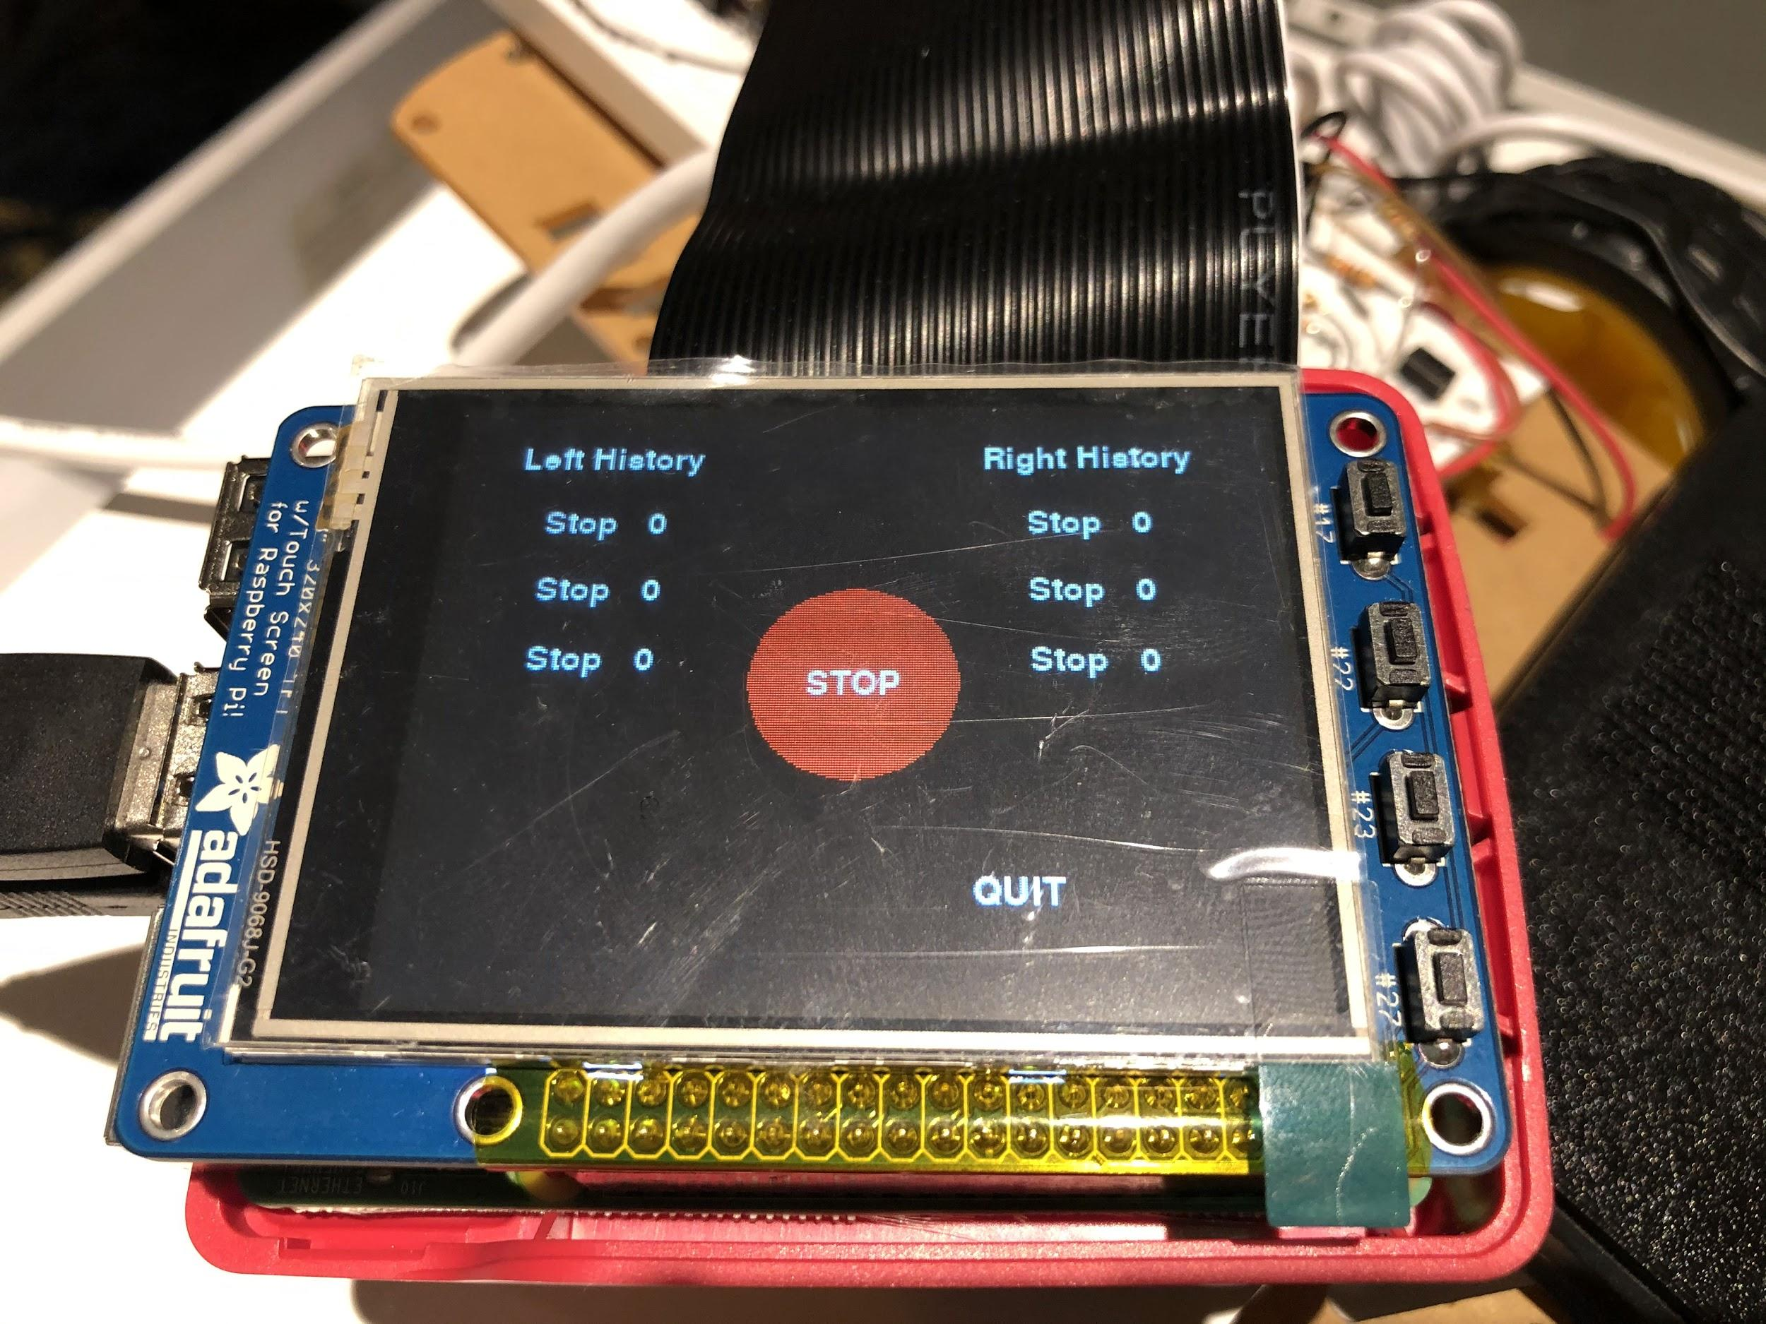

Figure 16 - Welcome display of rolling_control.py.

We can see the left and right history displayed, which initially have default values of “stop” at time 0. At this state, we can begin pressing the motor control buttons. The latest motor control passed to each motor will be on top of the history log. An example of the log after button presses is as below:

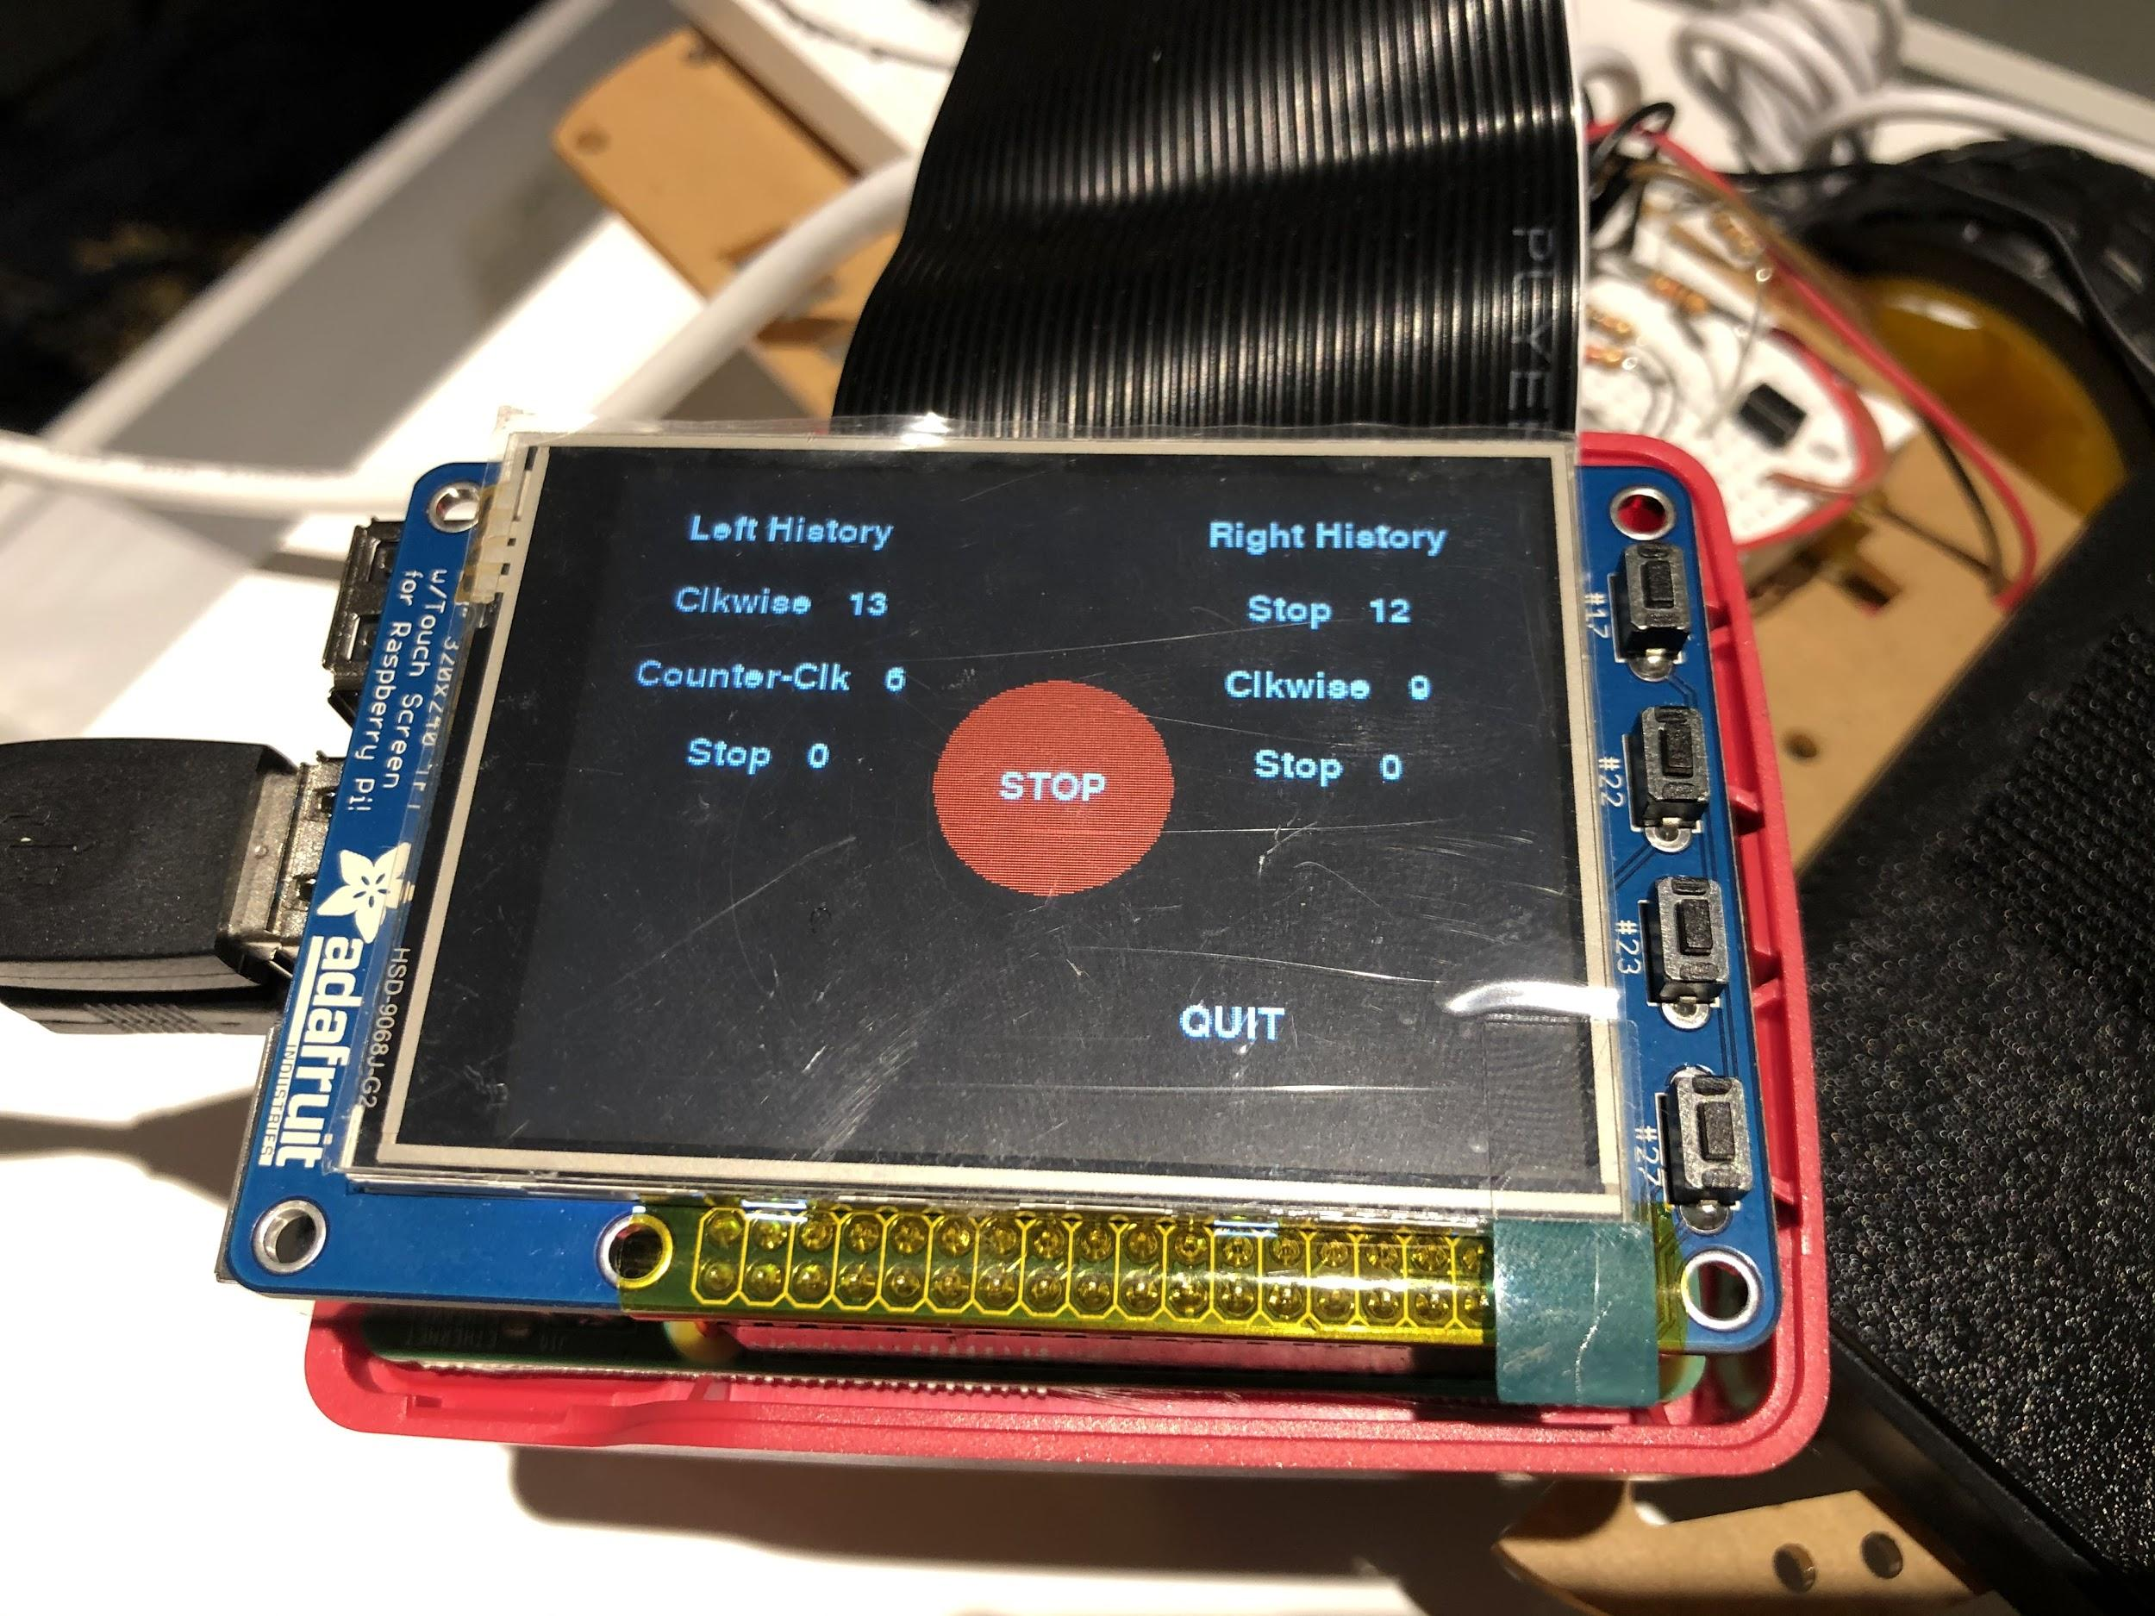

Figure 17 - The display of rolling_control.py after several motor commands.

In the image above, there has been a total of four button presses. The left motor counterclockwise is first performed at time of 6 seconds, then a right motor clockwise at time of 9 seconds, and so on. This shows that the log will actually record the motor commands passed and is displayed as expected. The motor will also move according to the passed motor control commands. In another instance, the “STOP” button is tested and the display is as below:

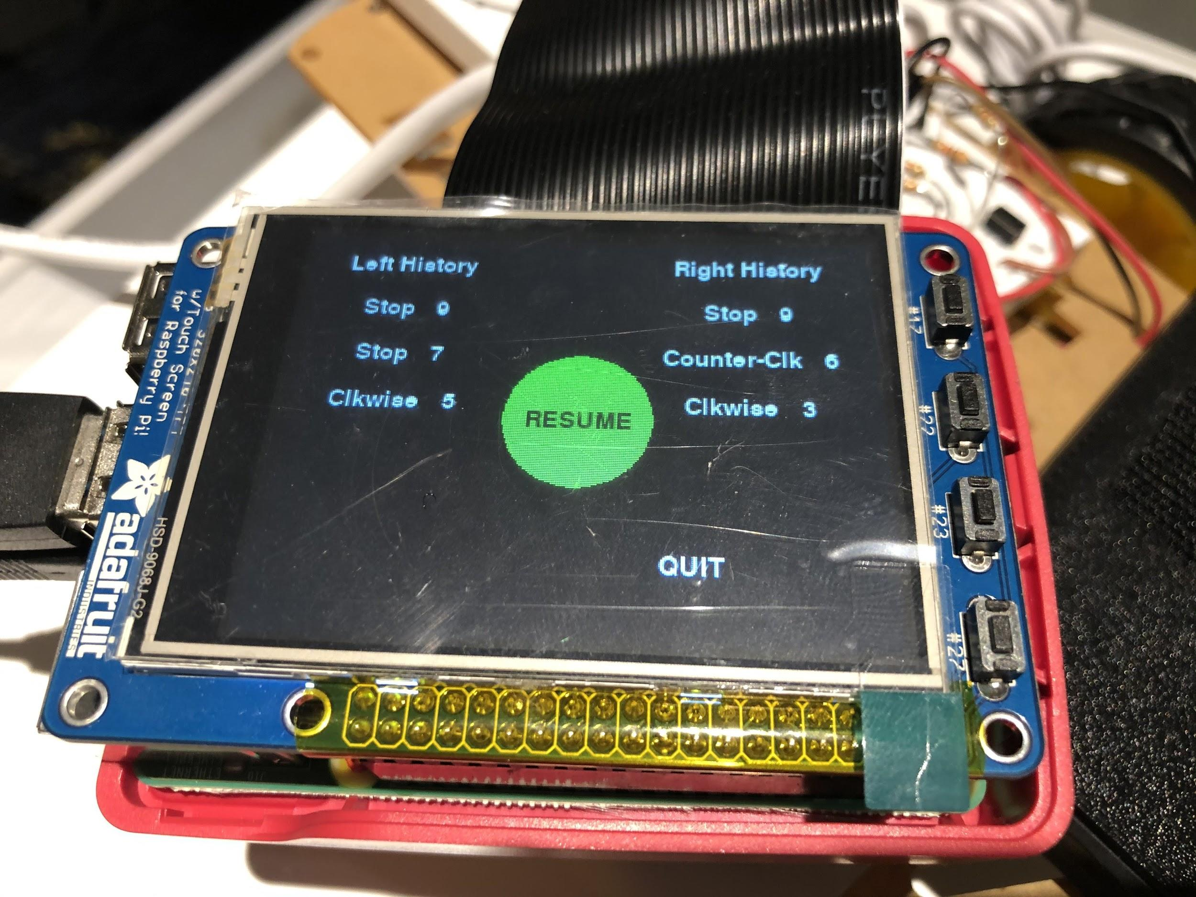

Figure 18 - The display of rolling_control.py after “STOP” button press.

After the stop button is pressed, the button will change to a “RESUME” green button. We can see that the last commands passed is the “Stop” command at time = 9s. This is because the “STOP” button will tell the motor to stop at that time. In this state, any button press will have no effect and none of the motors will run. We would have to press the “RESUME” button in order to pass more motor commands. In any instance, when the “QUIT” button is pressed, then the program will quit.

After the testing, we have confirmed that the program is working well. All of the expected outcomes are achieved. In this section, the main difficulty is in choosing the coordinates since there are a lot of things to be displayed on the screen. We also faced some issues in printing the colored circles for the buttons, which happened because we were passing the wrong parameters. This section has taught us how to create a user interface where the user can view some information as well as pass some commands (for the motors).

**Building the robot frame:**

In this section, the robot frame will be built. This robot frame will allow us to integrate the Raspberry Pi, motors, PiTFT, and circuits into a mobile robot. To best build the robot, it is advised to read the list of parts and instructions below: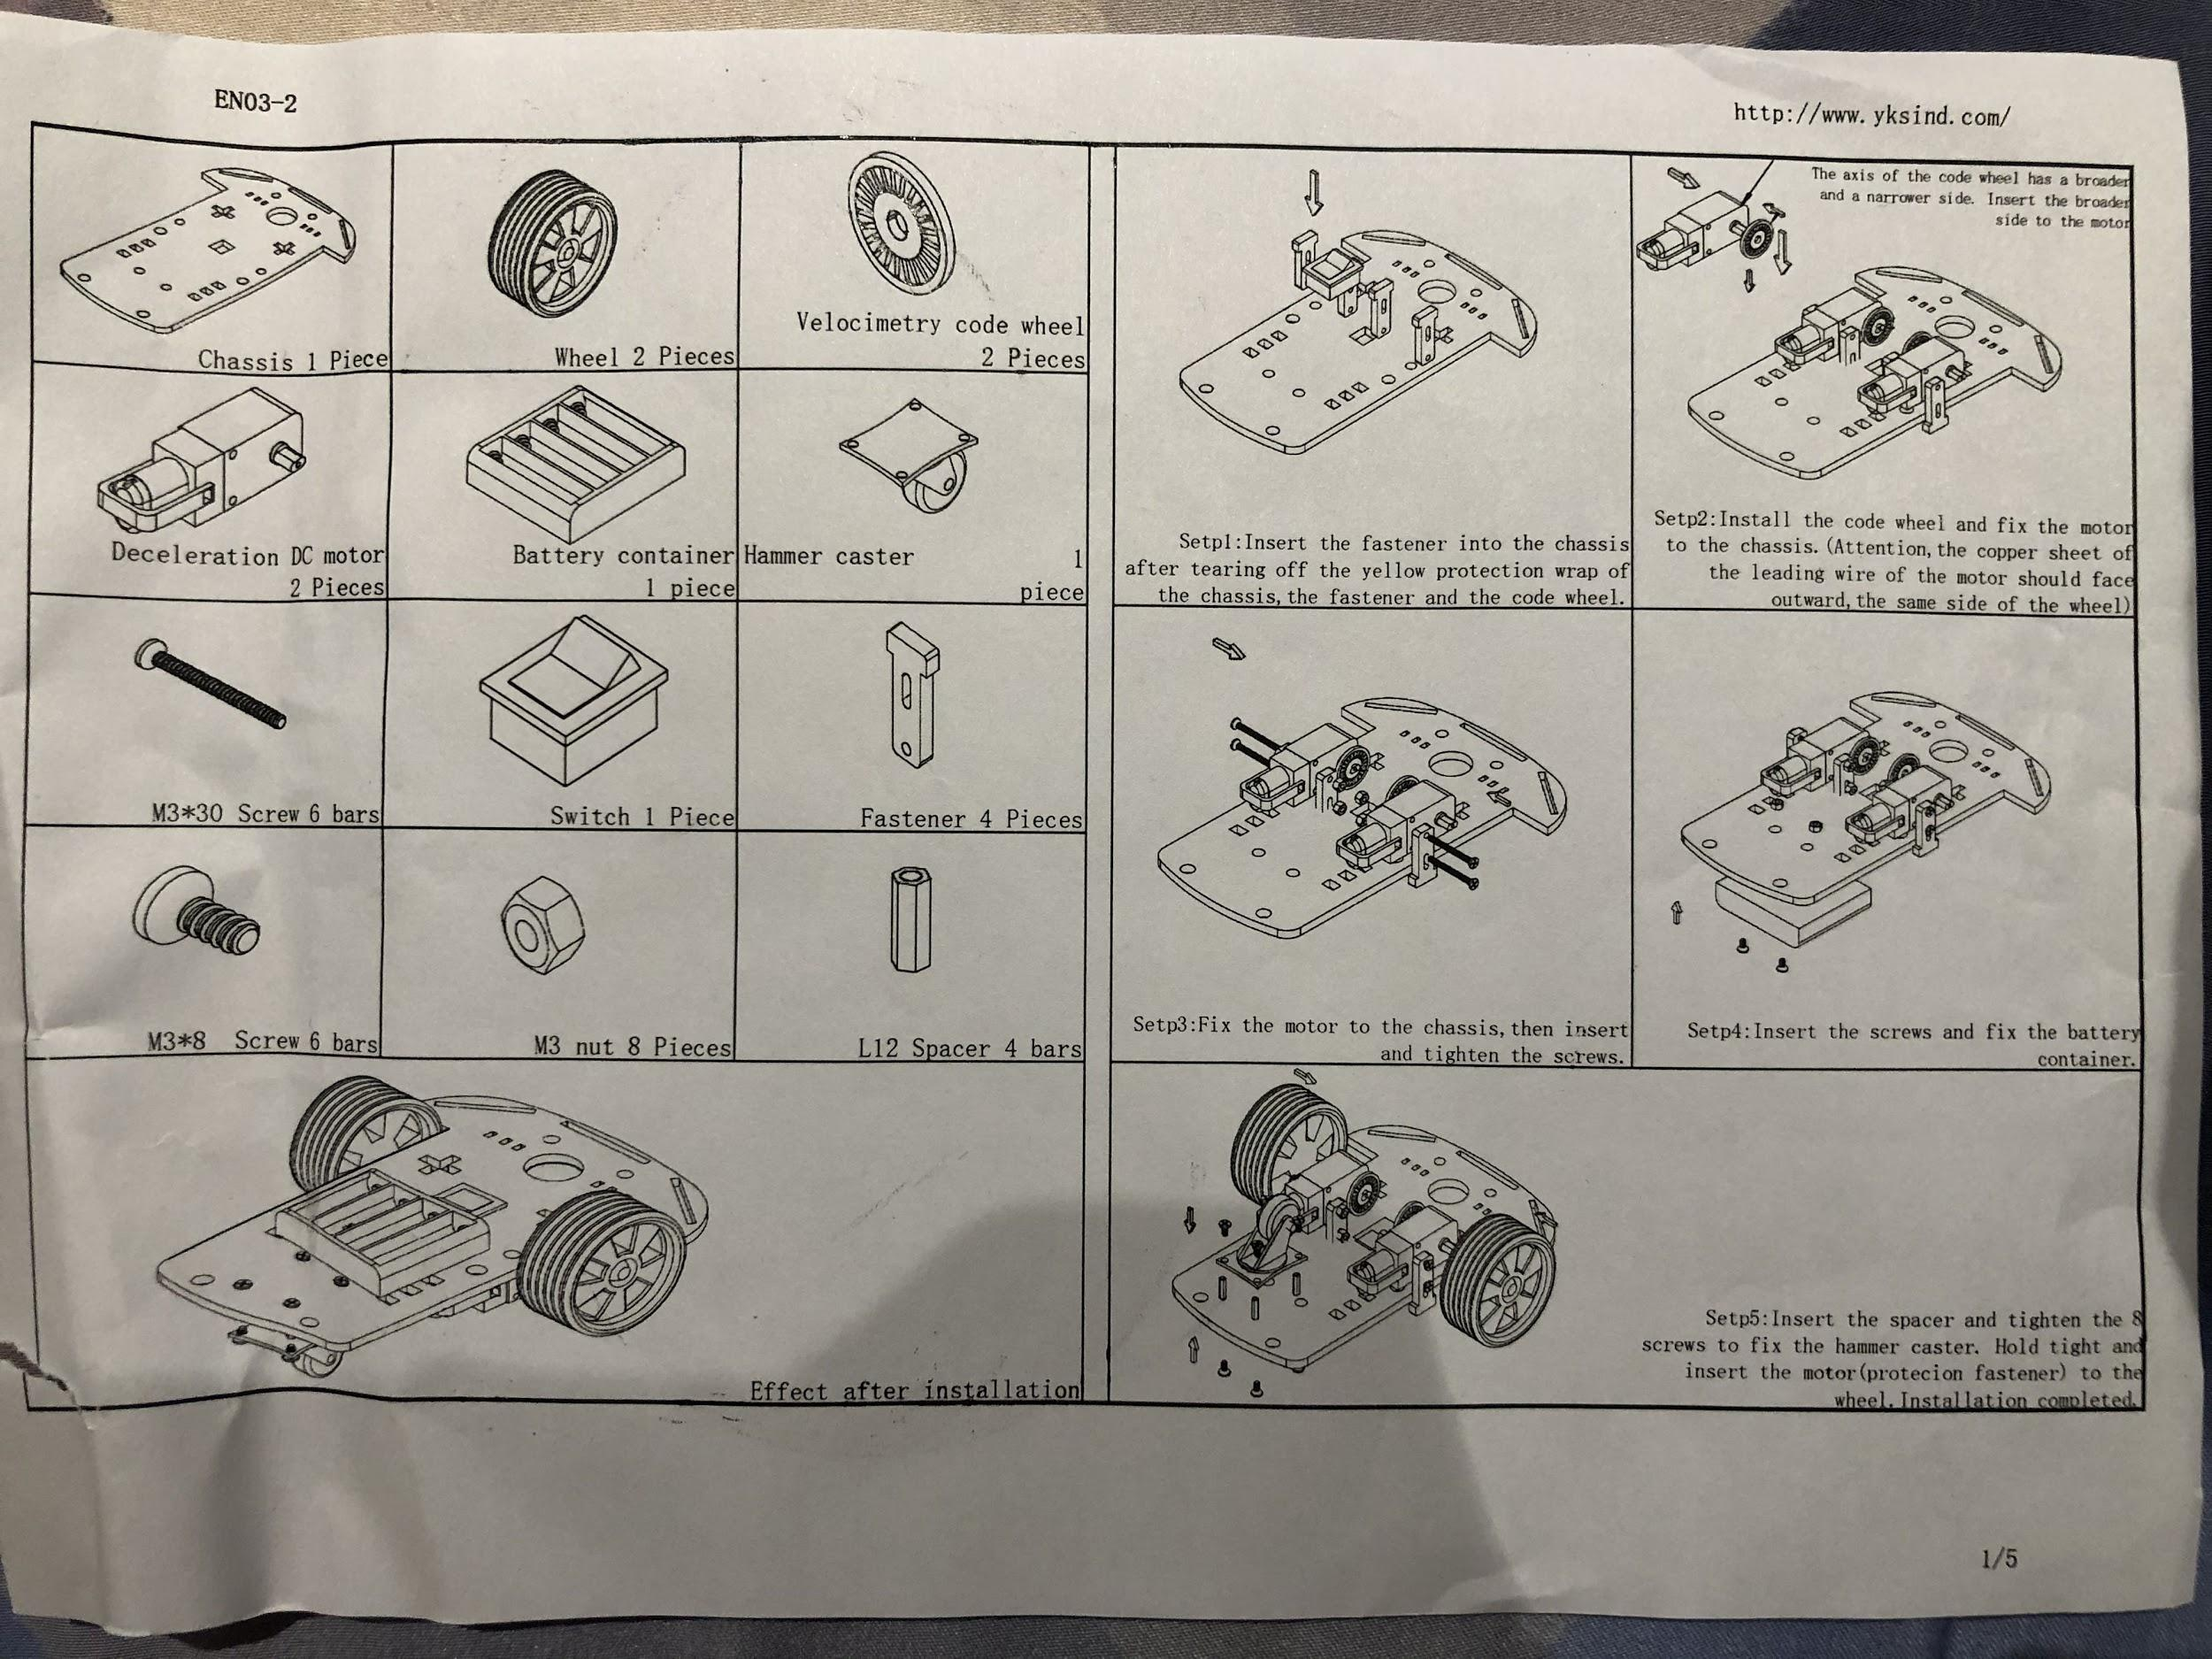

Figure 19 - The list of parts and assembly instructions.

First of all, the motor should be attached to the chassis. This is done by using the 2 fasteners that clip the motor in the middle. Then two M3x30 screws are inserted from the outer part of the chassis and are tightened with the nuts from the other side. The view from the outer part is as below:

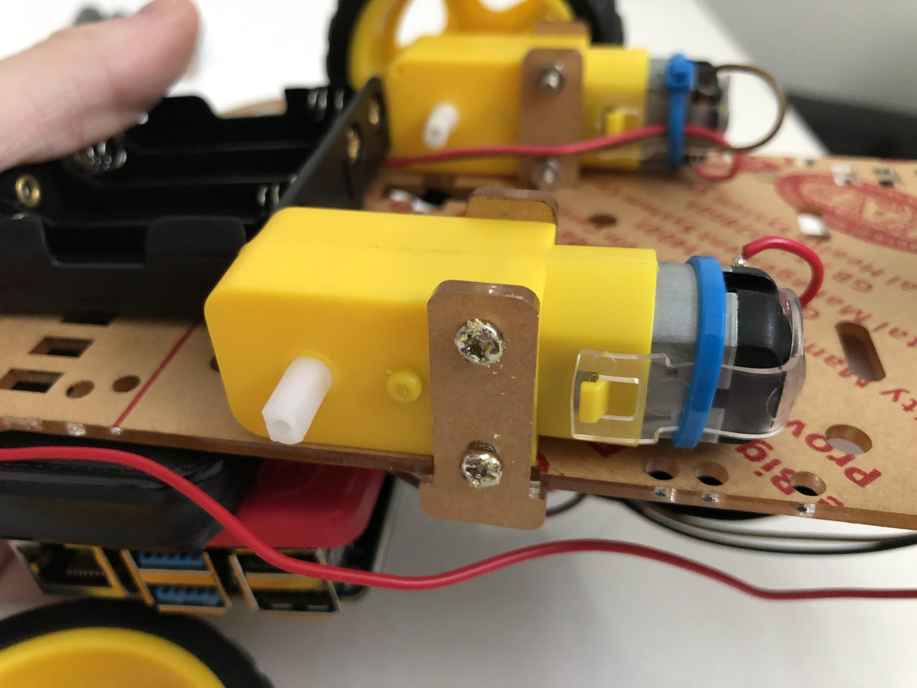

Figure 20 - The motor viewed from the outer section of the chassis.

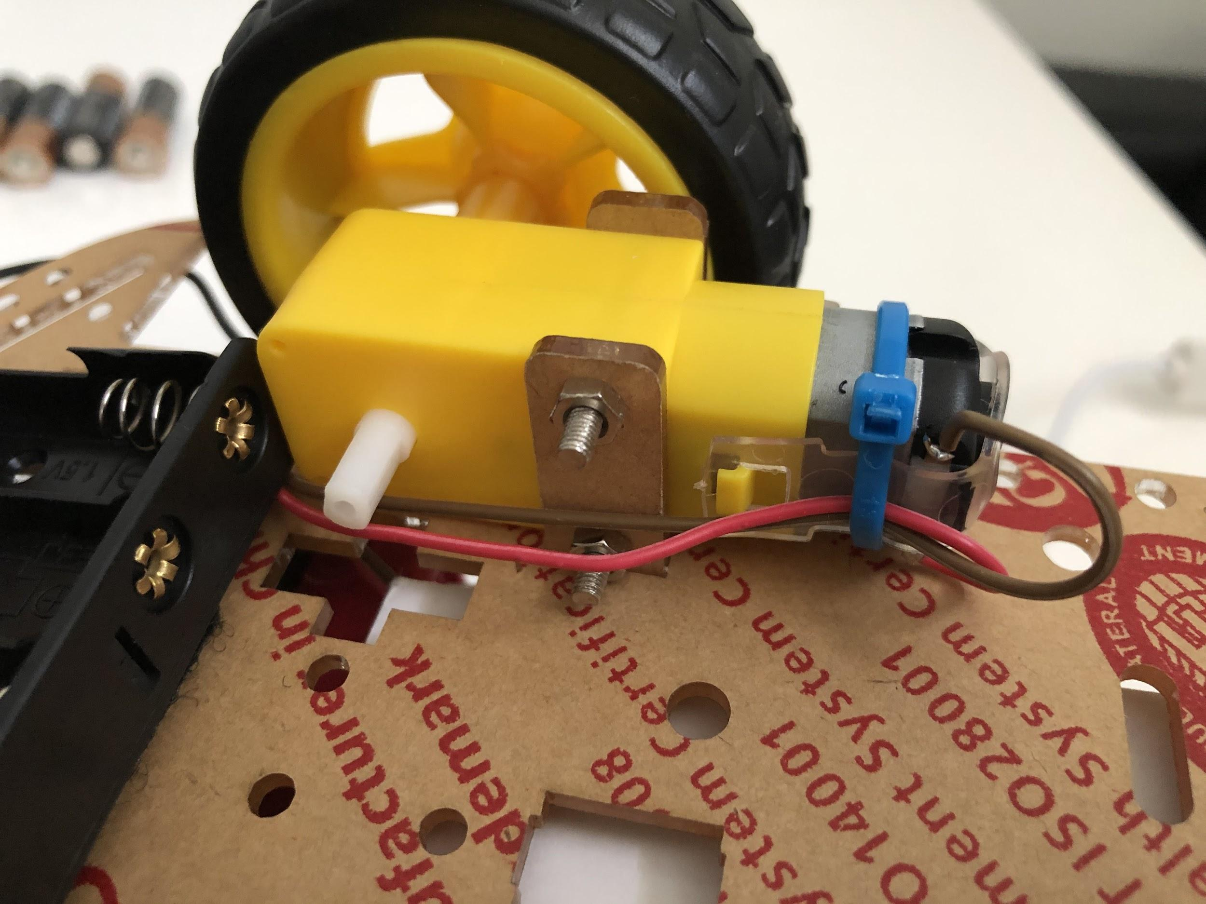

Figure 21 - The motor viewed from the outer section of the chassis.

Now that the motor has been tightened, the wheels can be attached to the outer motor axle and the velocimetry wheel can be attached to the inner motor axle. Also, the cable from the motor should be inserted into the hole above it, to allow the cable to be connected to the breadboard attached on the other side. A picture is shown below:

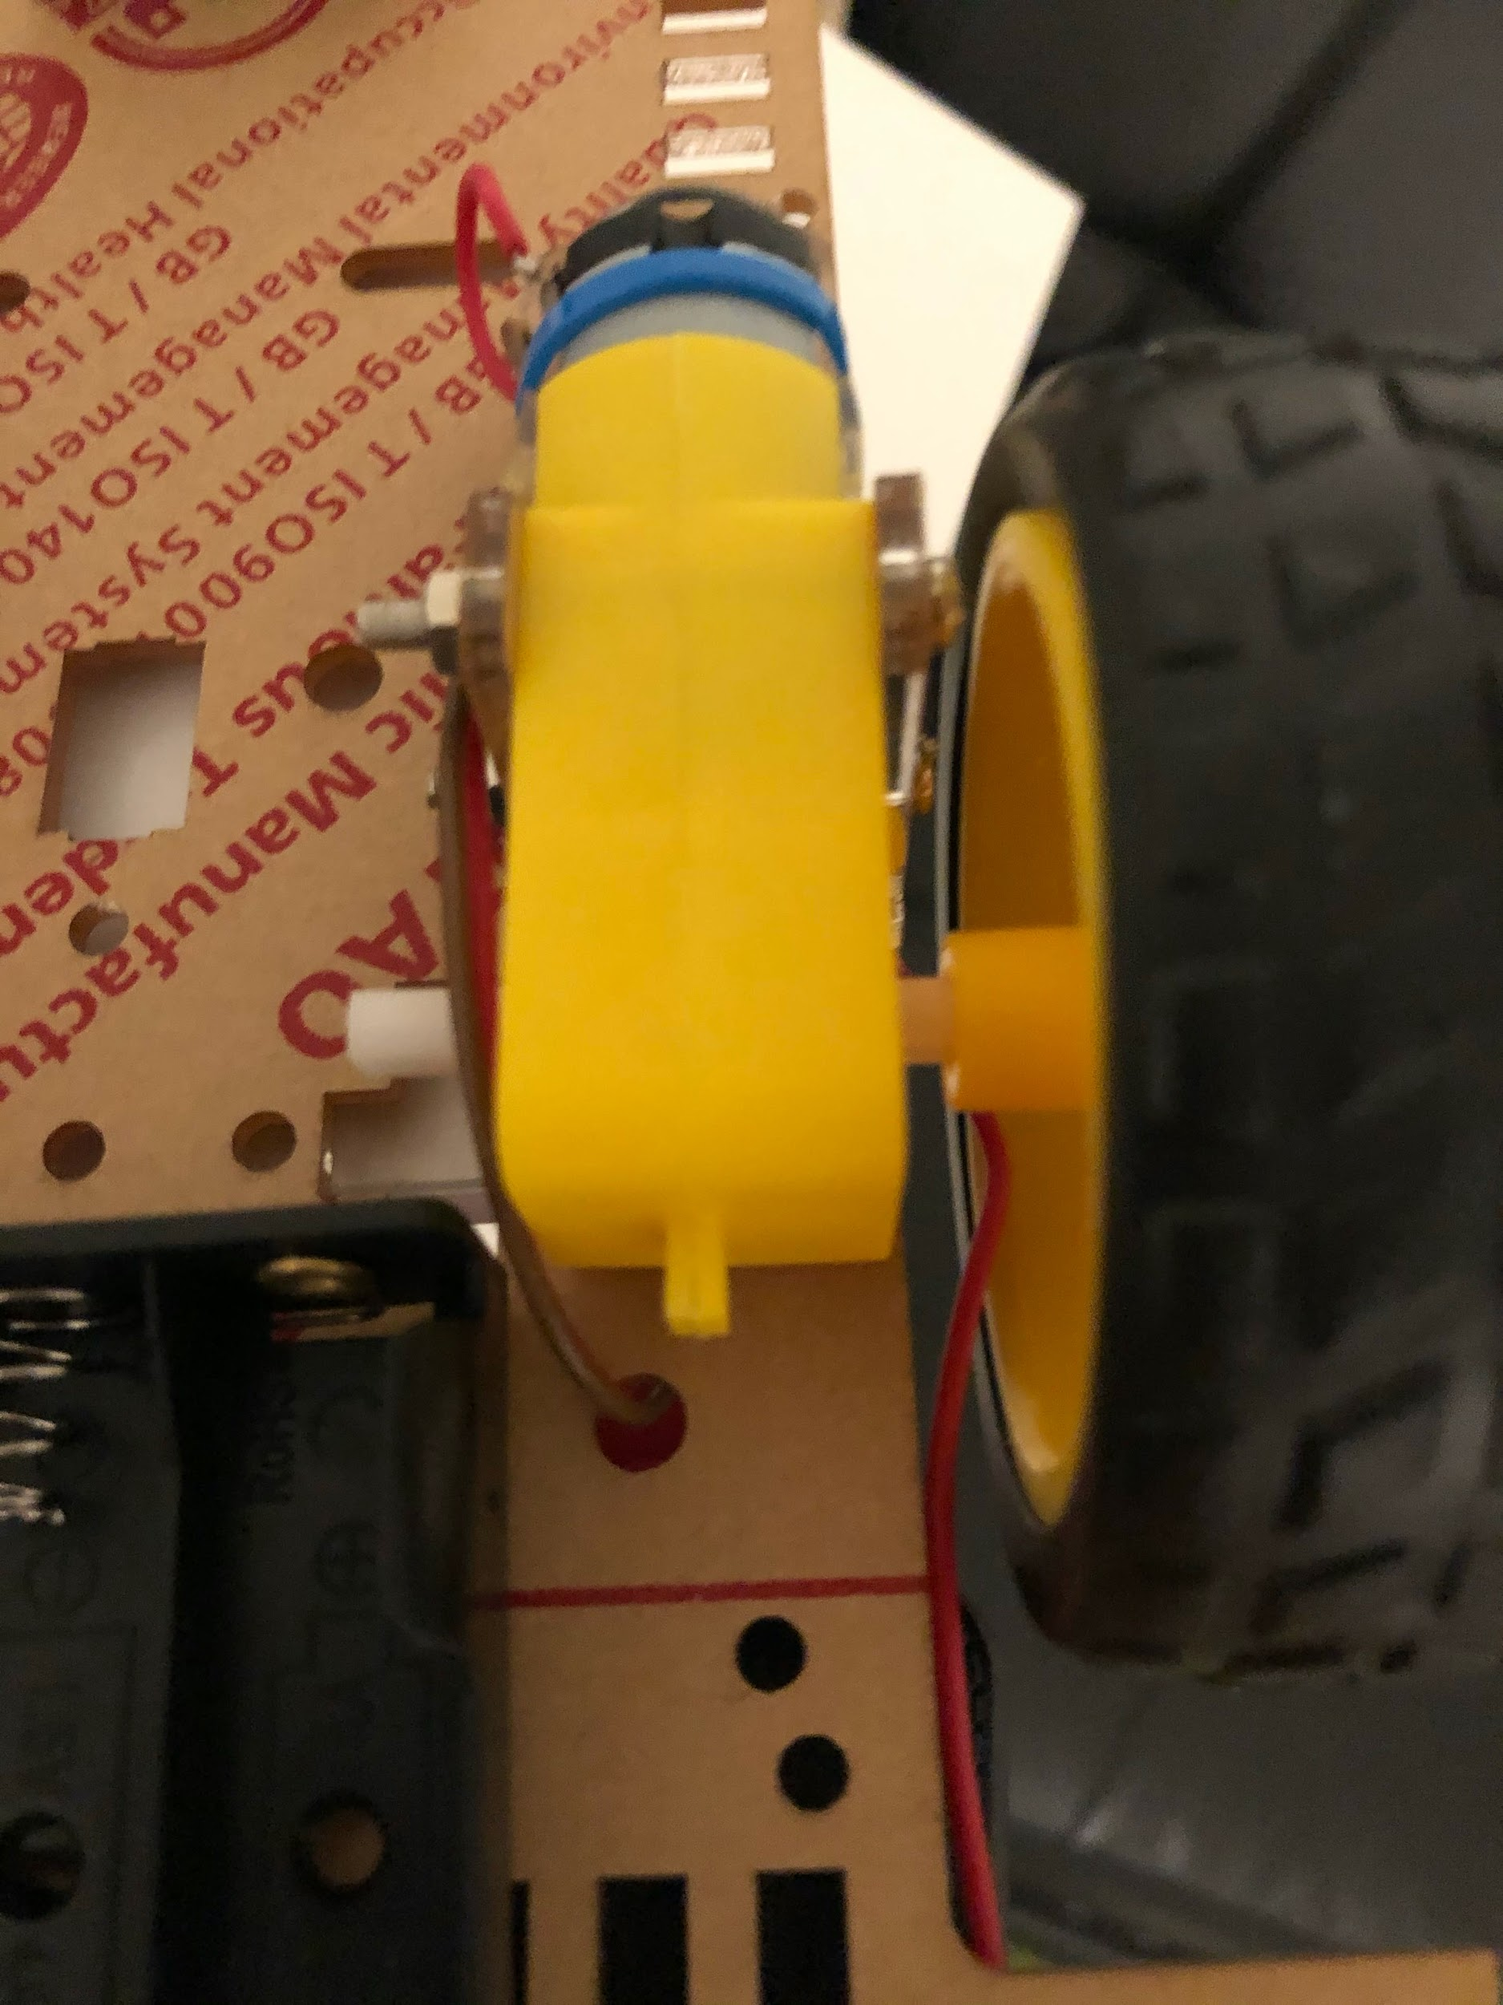

Figure 22 - The cable from the motor inserted into the hole below it.

Next, the caster should be attached to the squared-end of the chassis. It will be attached using 4 spacers and 8 M3x8 screws. 4 screws were used to attach the caster to the spacers and 4 screws were used to attach the spacers to the chassis. The end result is as below:

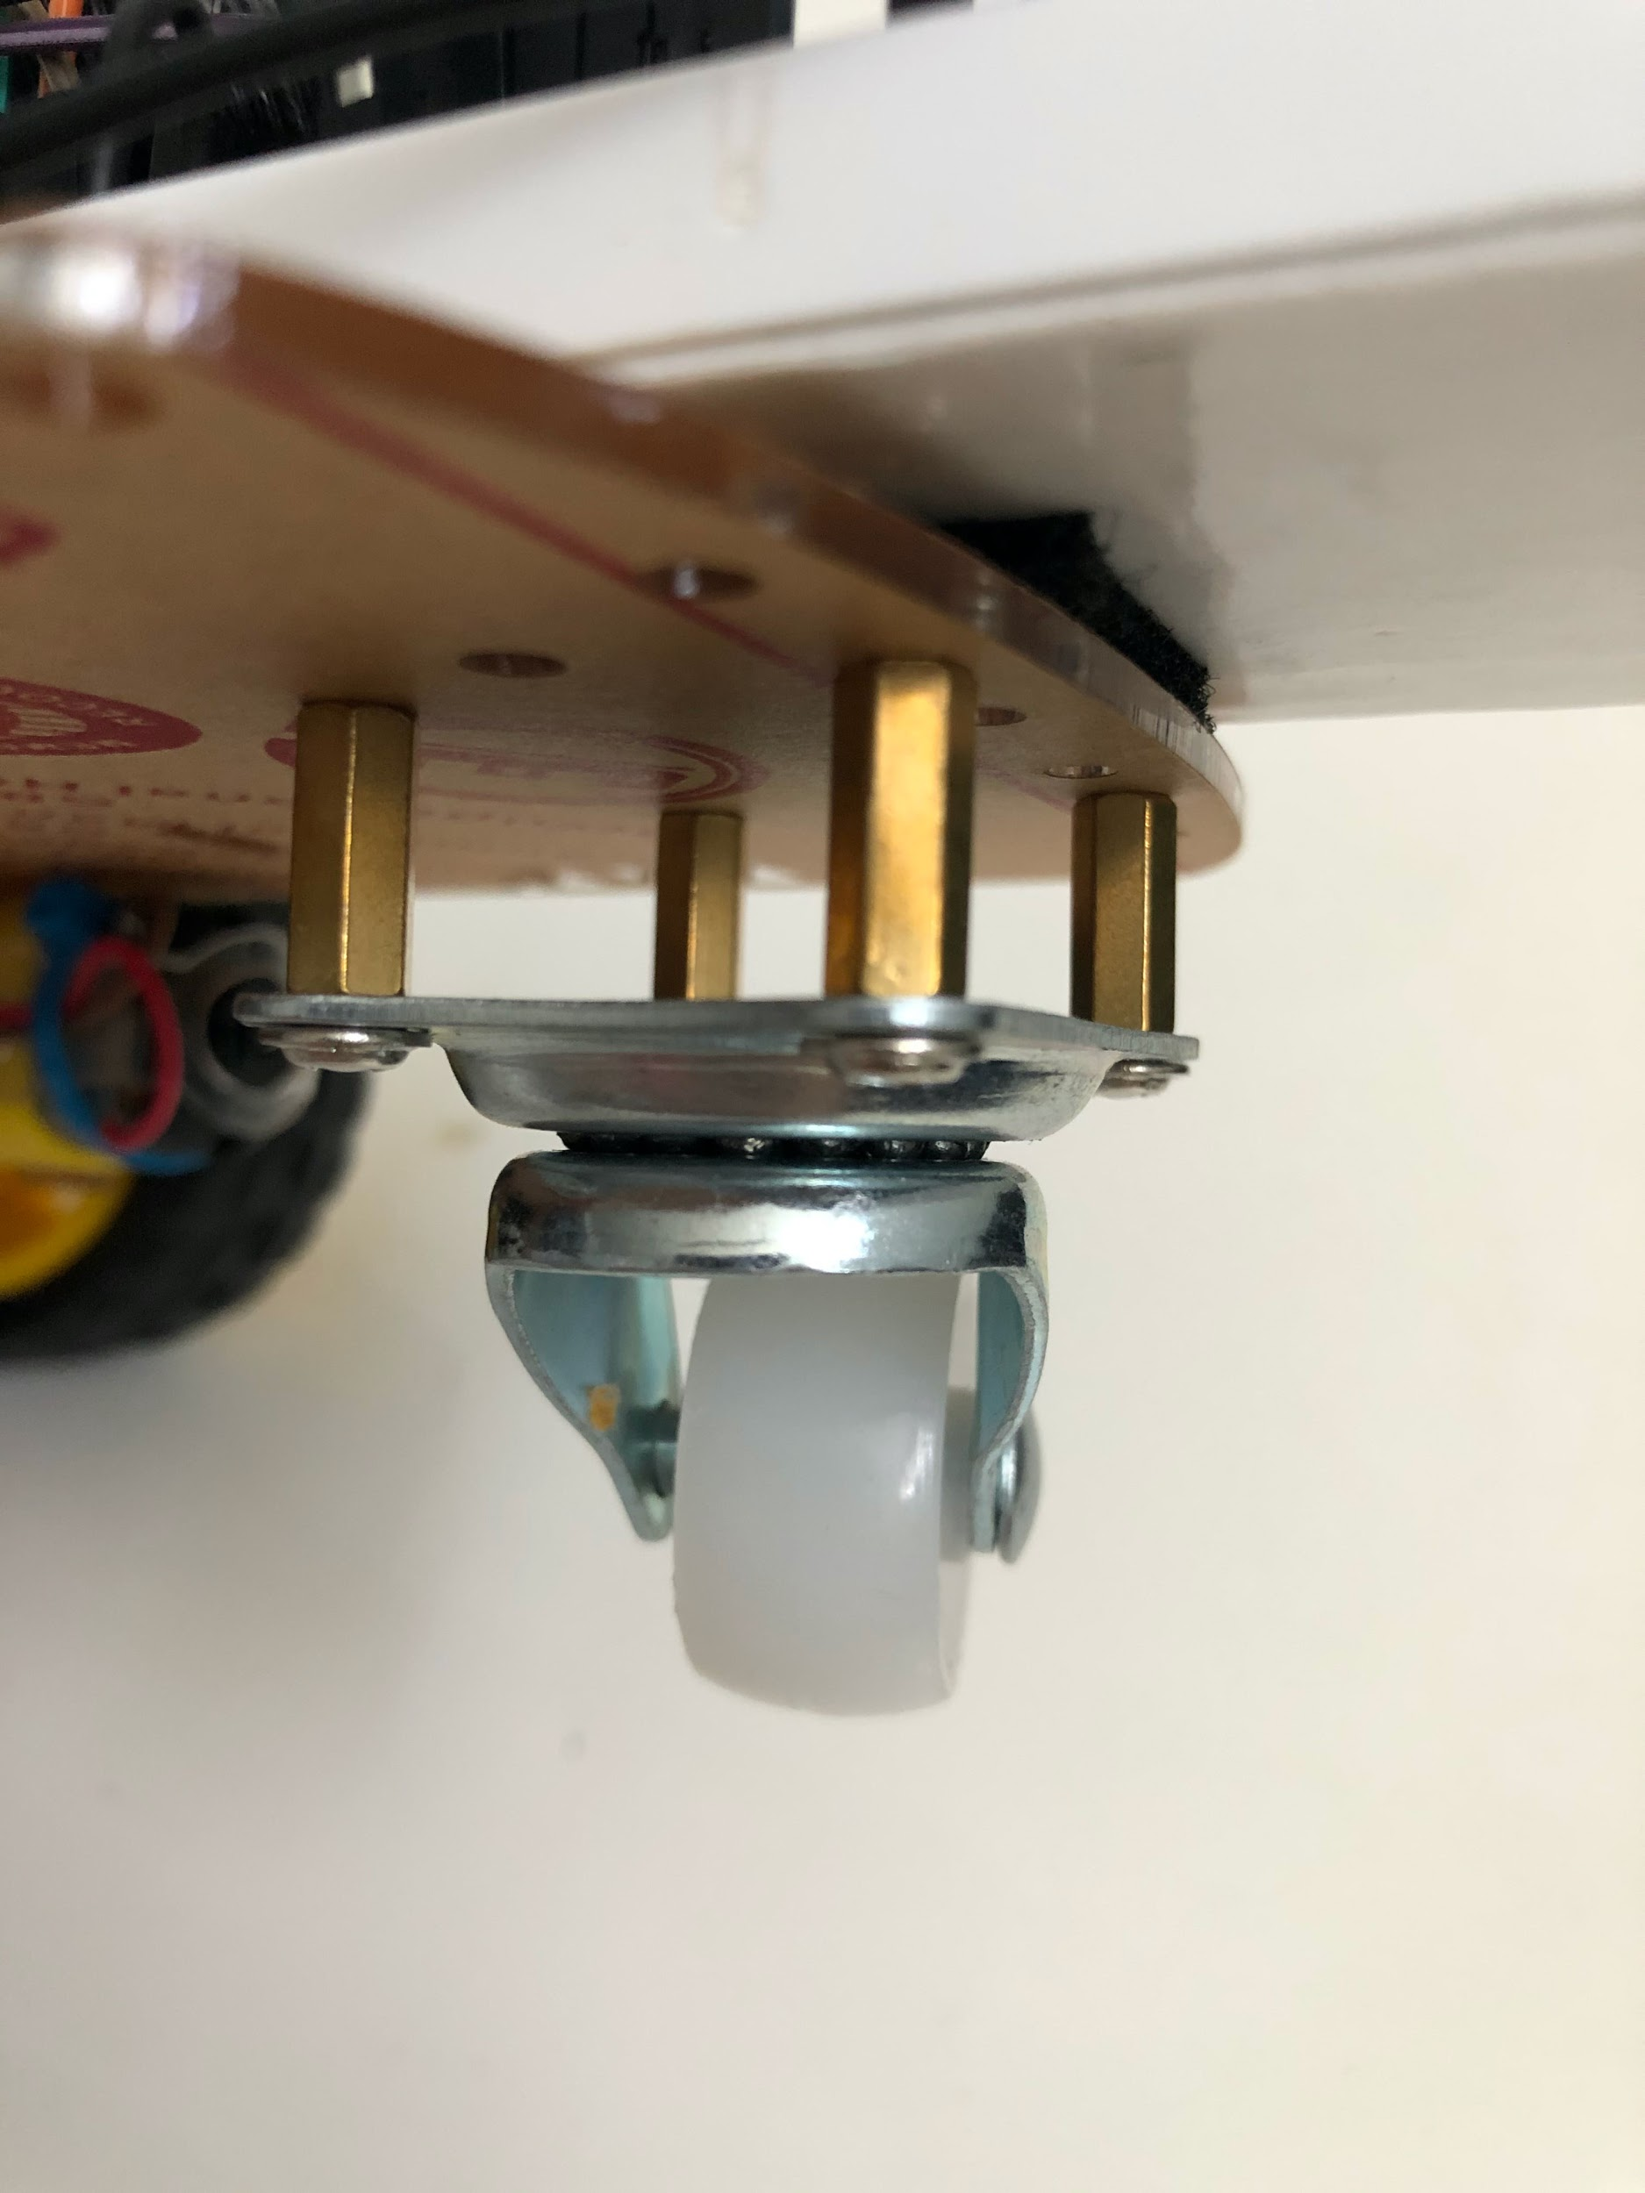

Figure 23 - The caster attached to the chassis.

Next, the battery pack holder should be attached to the bottom side of the chassis near the rounded end. A velcro is attached to the battery holder and then attached to the chassis. An example is shown below:

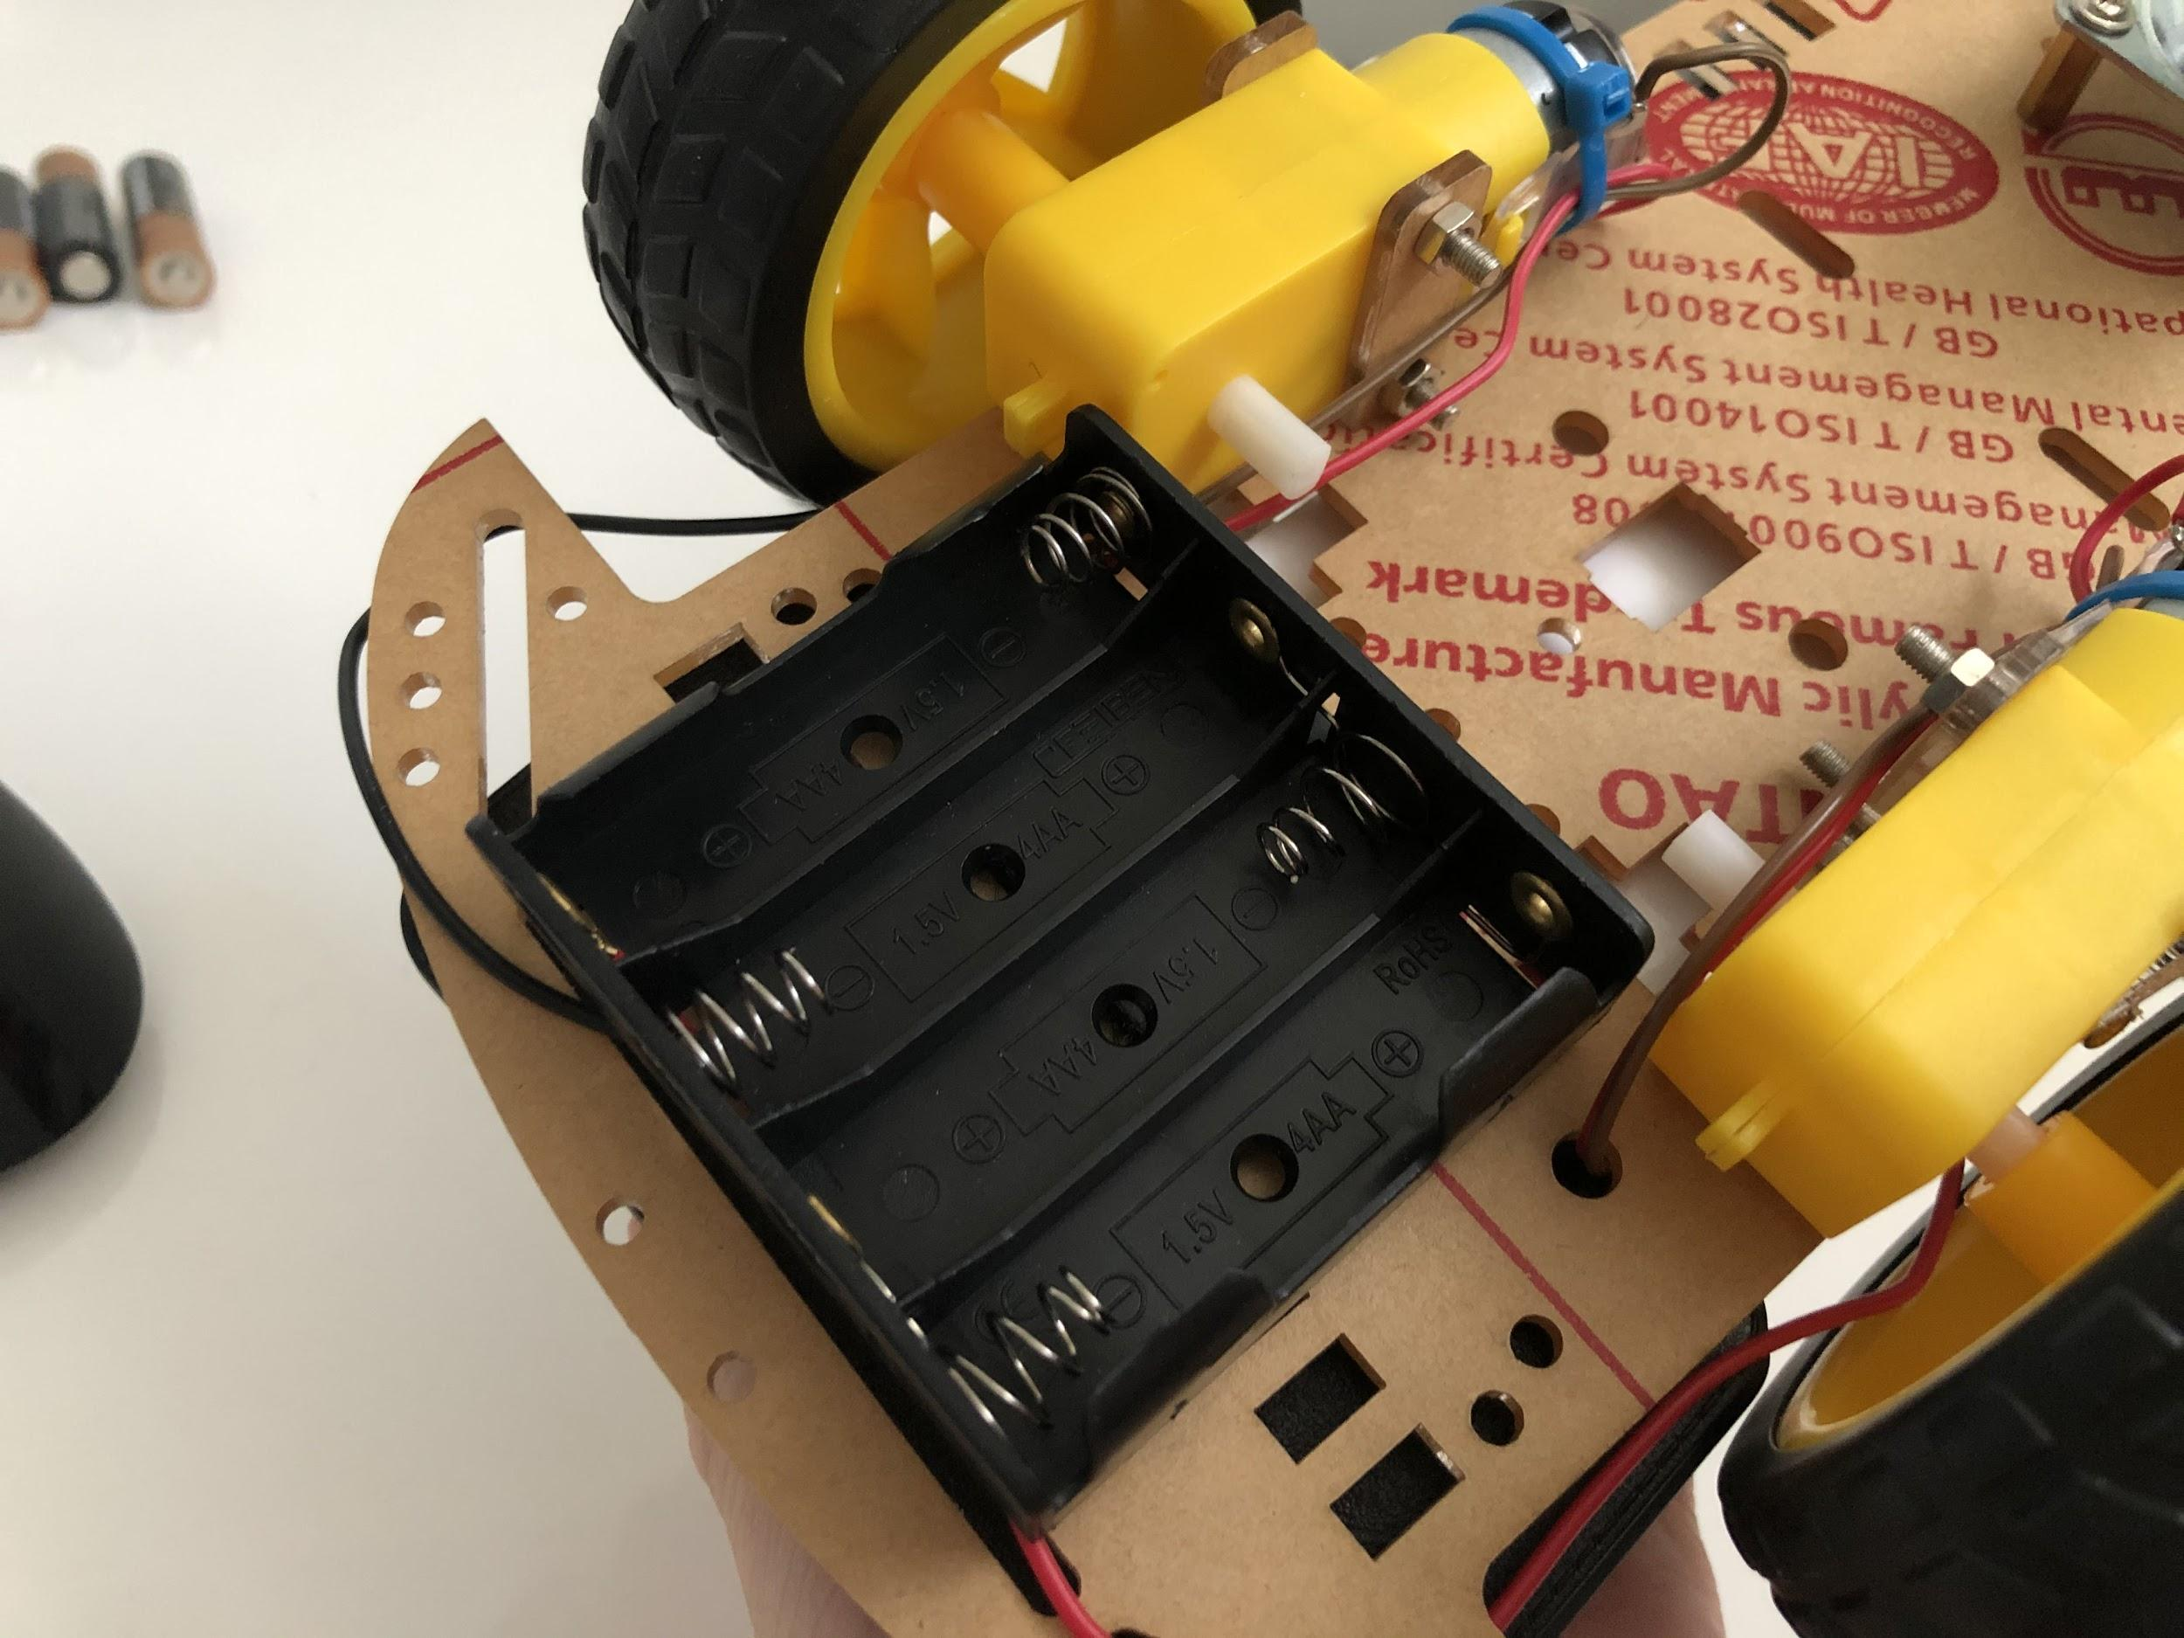

Figure 24 - Battery holder attached to the bottom side of the chassis.

Then, the RPi will be stacked on top of the portable battery using a velcro, which is attached to the rounded end of the chassis using a velcro too.

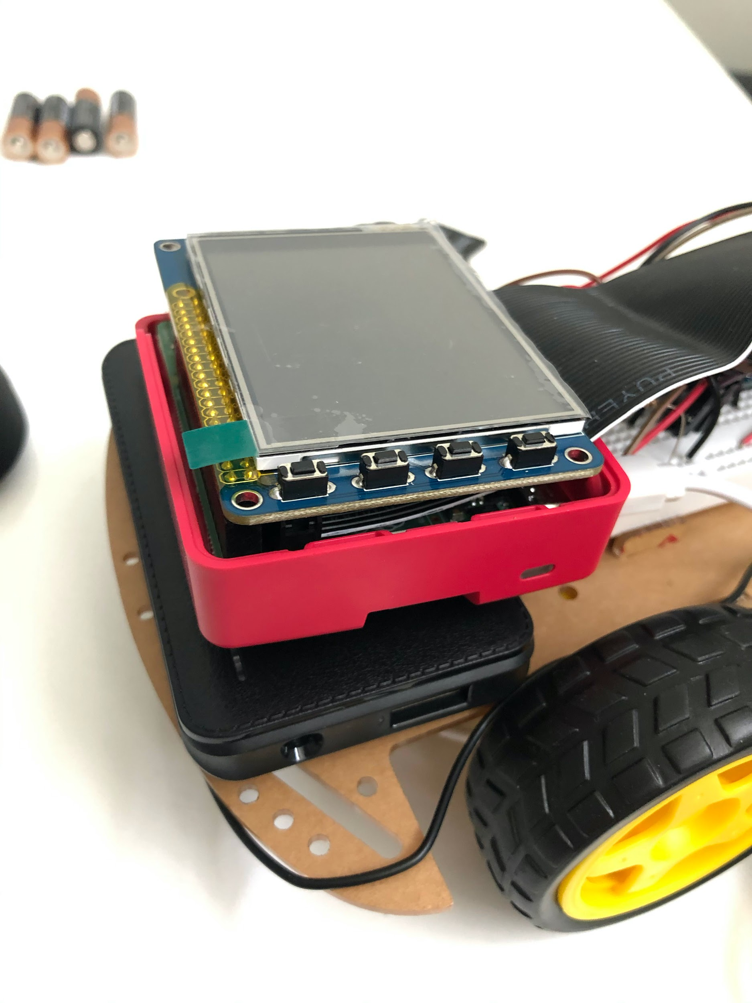

Figure 25 - RPi and battery attached to chassis using velcro.

Finally, the protoboard is attached using a velcro to chassis right next to the RPi. Once everything has been set up, the final result is as below:

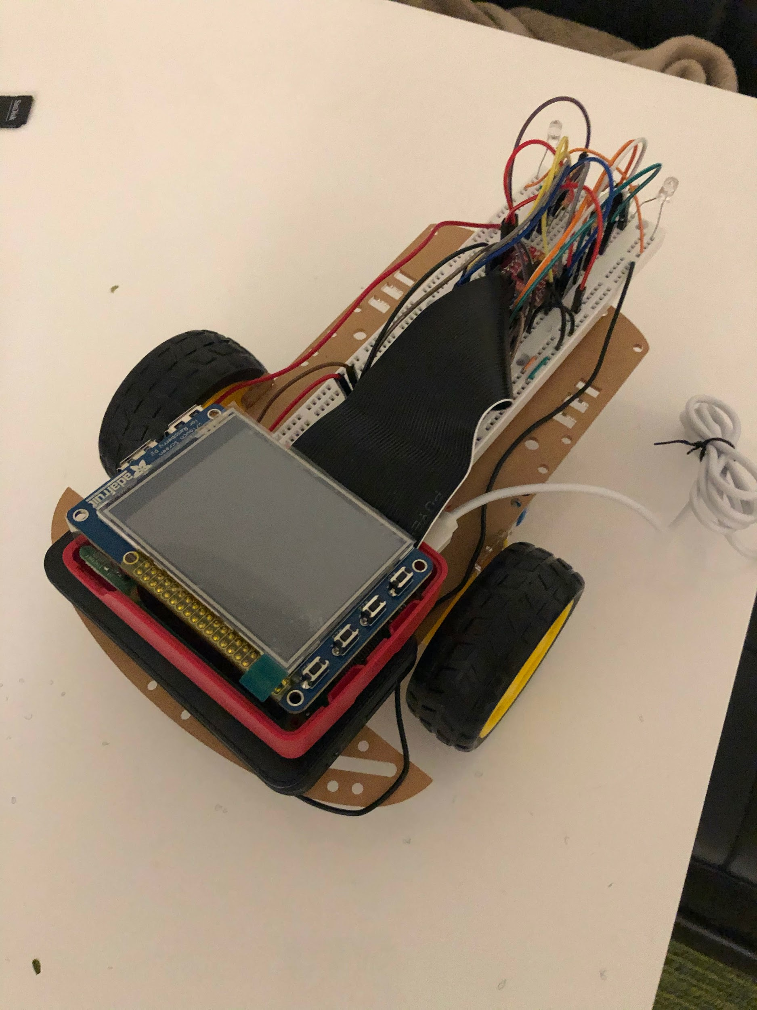

Figure 26 - The robot frame with attached RPi and circuitries.

This section is pretty straightforward if the instructions are followed carefully. We did not face any difficulties in this section. The robot is now ready to experiment where we can now design programs that will move the robot.

**Run test code:**

In this next section, we will be creating a motor movement simulation with the program “run_test.py”. This program will be built from “rolling_control.py”. The robot should perform these movements in a loop:

* Move forward for about 1 foot
* Stop
* Move backwards for about 1 foot
* Pivot left
* Stop
* Pivot right
* Stop

The program should have all of “rolling_control.py” functions such as the “QUIT” button and “STOP” button. Additionally, this program should include an additional button on the display, which is the “START” button. The program of robot movement simulation will basically not start until that button has been pressed.

Firstly, there are some minor changes in this program compared to “rolling_control.py” . In the button dictionary, the following “START” button is added with the following coordinates: 'START':(100, 200. A “start” variable is also created to store the value on whether the “START” button has been pressed. It is first initialized as False. Then, in the control function, the commands should only be called if “start” is True. Additionally, the duty cycle of the PWMs is decreased to 50% to have the robot go slower during the simulation.

Next, there are several changes in the main while loop. There is an additional check in the MOUSEBUTTONUP event, which will now check if the “START” button is pressed: elif y > 180 and y < 220 and x > 80 and x < 120:

print("Start button is pressed")

start = True

This code snippet will check if the touch is within the range of the “START” button: 180<y<220 and 80<x<120.

The main major change will be at the end of the main while loop. This is where the robot movement simulation is performed. There will be several variables that are created outside the main loop:

step = 1 # Initialize step at 1

required_time = 0

step_start_time = 0

The “step” variable defines the current state of the simulation. As described at the beginning of this section, there will be a total of 7 stages that will continuously loop around. The “required_time” will define how long that stage/step will require, and it is measured in seconds. Lastly is the “step_start_time”, which is the variable that will store the start time of the step/stage.

The code that loops around the steps/stages is long, but is displayed here as it is essential to provide a good explanation of how it works:

if start == True and stop == False:

if step == 1 and (time.time() - step_start_time) > required_time: # Forward

control(1, 2)

control(2, 1)

required_time = 1

step_start_time = time.time()

step = 2

elif step == 2 and (time.time() - step_start_time) > required_time: # Stop

control(1, 0)

control(2, 0)

required_time = 1

step_start_time = time.time()

step = 3

elif step == 3 and (time.time() - step_start_time) > required_time: # Backward

control(1, 1)

control(2, 2)

required_time = 1

step_start_time = time.time()

step = 4

elif step == 4 and (time.time() - step_start_time) > required_time: # Left

control(1, 1)

control(2, 1)

required_time = 1

step_start_time = time.time()

step = 5

elif step == 5 and (time.time() - step_start_time) > required_time: # Stop

control(1, 0)

control(2, 0)

required_time = 1

step_start_time = time.time()

step = 6

elif step == 6 and (time.time() - step_start_time) > required_time: # Right

control(1, 2)

control(2, 2)

required_time = 1

step_start_time = time.time()

step = 7

elif step == 7 and (time.time() - step_start_time) > required_time: # Stop

control(1, 0)

control(2, 0)

required_time = 1

step_start_time = time.time()

step = 1

This section of the code will only run if the “START” button has been pressed and the program is not in the “stop” state when the “STOP” button has been pressed. The if conditions will first check on the step/stage that currently needs to be executed. It will also check whether the previous stage has run for enough time. This is checked by: (time.time() - step_start_time) > required_time. Since the step_start_time is given the time value when a particular step is executed and required_time is defined for each step, the calculation above will check if the required time has been met. For a better explanation, the third step will be explained. It will first check if “step” variable has a value of “3”, and that the previous step has (which would be step 2), has already run for enough time. Then, two control commands function will be called. In this case, since we wanted to move backward, then the right wheel is set to move counterclockwise and the left wheel is set to move clockwise. Then, the “required_time” and “step_start_time”, and “step” are given new values, where “step_start_time” will have the time.time() value and “step” will be the next step to be executed.

With all of the changes above, the program is complete and it is time to test it. The RPi is now fully attached to the robot and getting the power from a portable battery. When the program first starts, the display is as below:

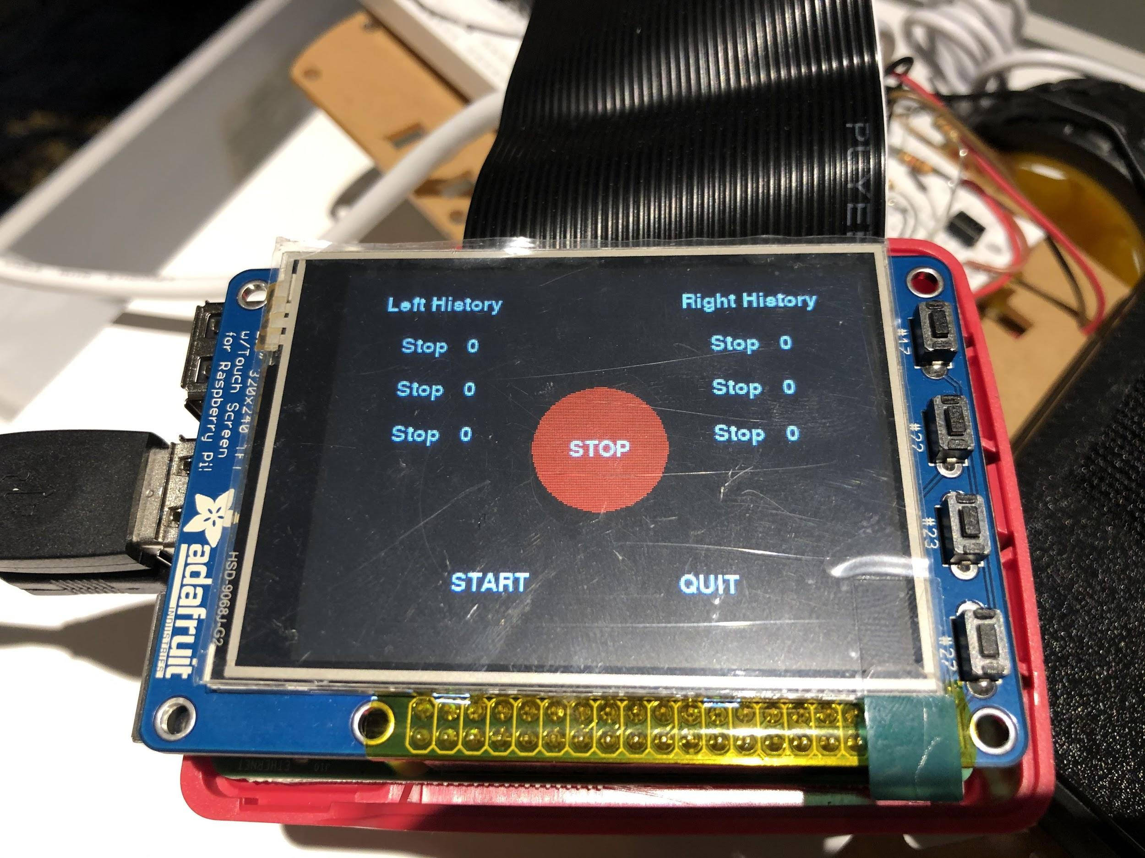

Figure 19 - Display of “run_test.py” when it first starts.

We can see that it now has a ‘START” button. The robot will not start moving unless the button has been pressed. When the “START” button is pressed, then the robot will start its movement simulation. The robot will move as required through the different steps, such as moving forward for one foot, then stopping, then moving backward for one foot, and so on. The display below shows when the robot is in step 7 (last step of stopping):

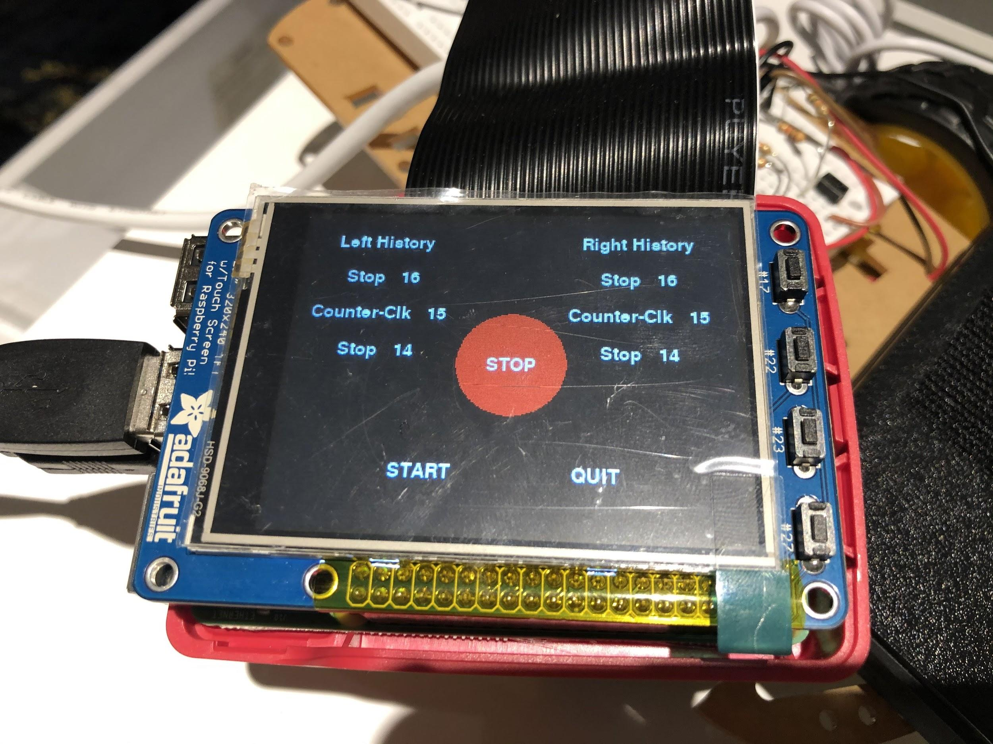

Figure 27 - Display of “run_test.py” during the simulation.

We can see the last three commands in the history logs, which are step 5, 6, and 7. The “STOP and “RESUME” buttons are also tested as shown in the image below:

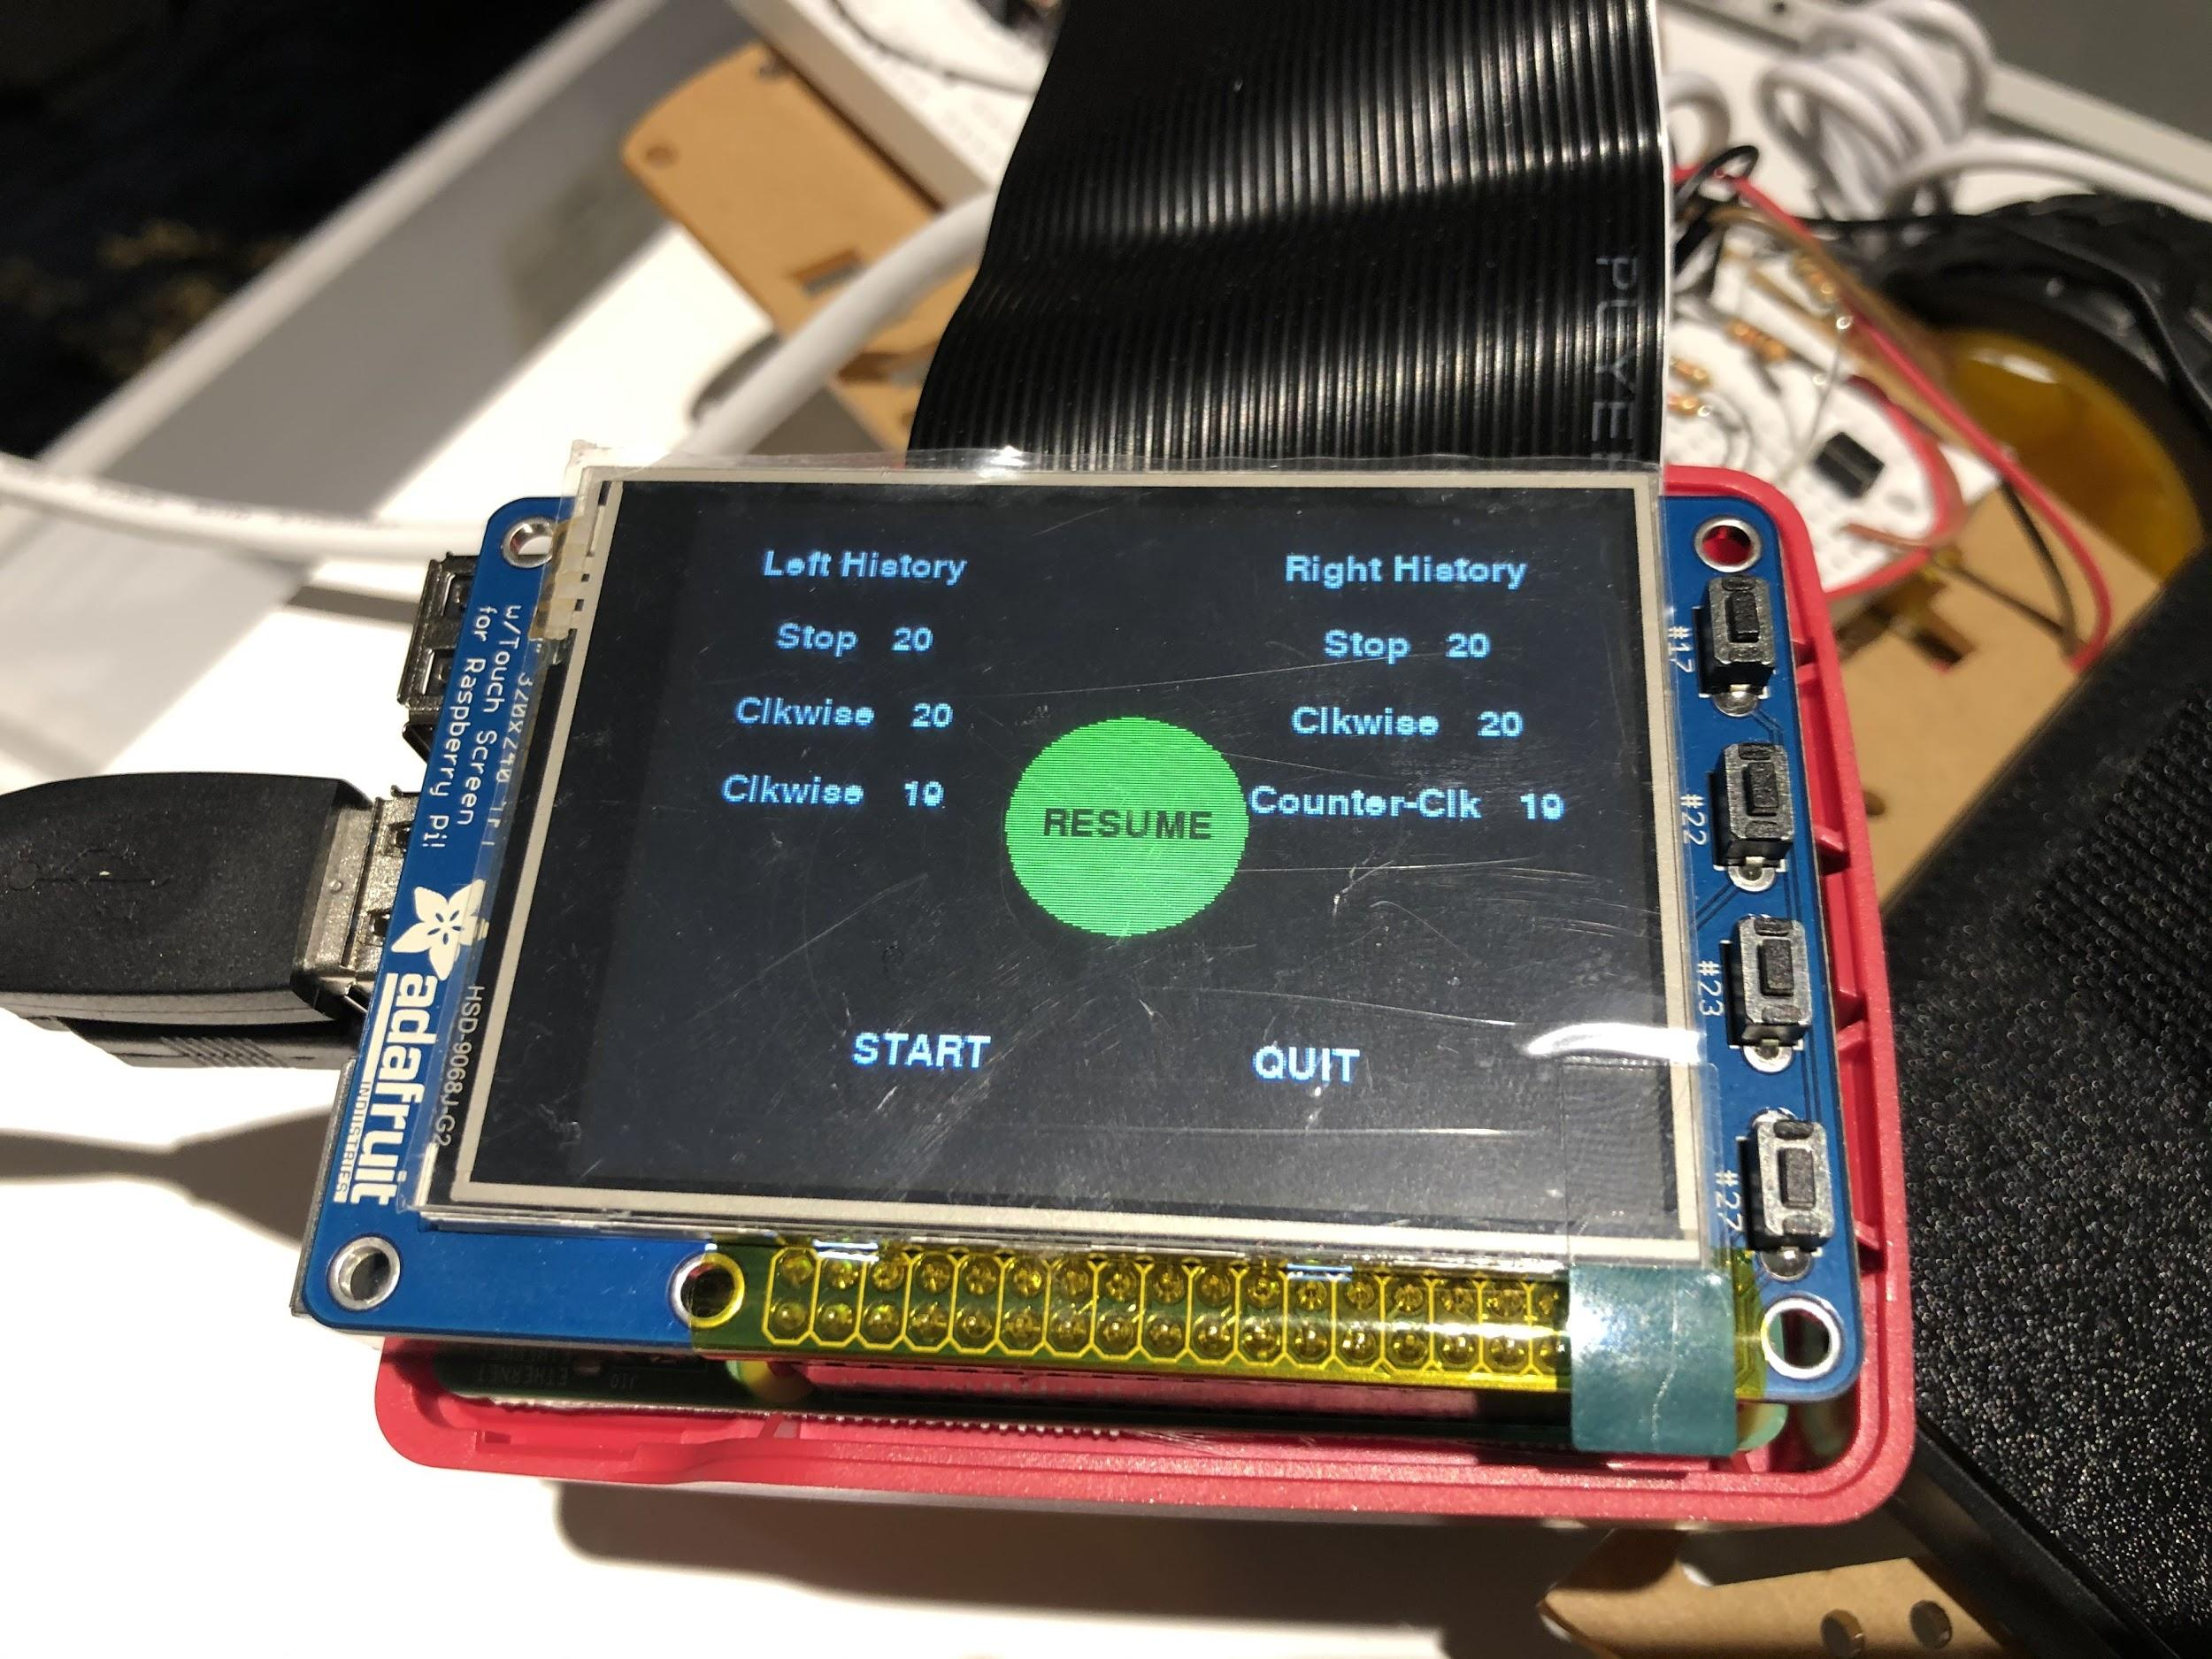

Figure 28 - Display of “run_test.py” during stop state.

The image above shows when the “STOP” button has been pressed. We can see how the last command passed in the log is the stop command. At this point, the robot is not moving. When the “RESUME” button was pressed, the robot continued to run the next step in the loop. At any point in time, when the “QUIT” button is pressed the program will quit. The “START” button is no longer functional after it has been pressed once.

The Figure below shows the RPi installed on the robot frame:

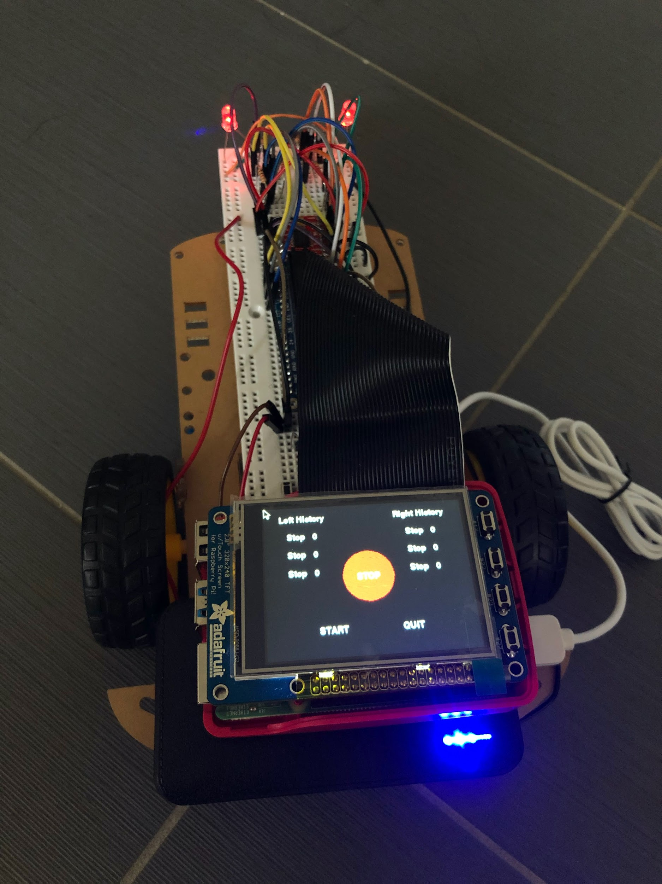  
Figure 29 - RPi installed on robot frame running “run_test.py”.

Overall, the program will perform the required robot movement simulation. At the same time, the different functionalities like the “STOP” and “RESUME” buttons are working as expected. In this section, we have learned how to create a simulation for a robot movement, which would allow us to automatically test the different motor control. We have also learned about creating a more complex program that involves a simulation, pygame display, and user inputs. The main challenge in this section is on deciding on how to perform the loop between the different steps of motor movement. Bugs are also faced when experimenting with the program. As a result, we took quite a while in doing this section.

At the end of this section, a backup is made for the microSD card of the RPi, which will allow us to restore this back up if anything happens. This is very critical as we are messing with the boot files in the next section, where we have a higher risk of potentially needing to restore the RPi.

**Configure RPi to launch from boot:**

Now that our program for our robot is ready, it is time to configure a way on how we can start this program automatically. This can be done by making configurations to have this run_test.py program to be launched when the device is booted.

The way to do it is to open /home/pi/.bashrc. Then, at the very bottom a line is added to start this program. The following line is added:

sudo python /home/Desktop/ECE5725/Lab3/run_test.py

Notice how we had to use sudo so that the file is executed as an admin and that the path added requires a full path. The Pi is now restarted and the program will actually run on startup after logging in.

Next, we would make this program to be able to run without logging in. So, we first run:

sudo raspi-config

Then, we select “Boot Options”, then ‘Desktop/CLI”, then “Console Login”. This change will allow us to boot to the device and enter the terminal shell without requiring us to log in.

Now that this configuration is added, we will see how the run_test.py automatically starts upon boot up without requiring the user to log in. The main advantage of this is how we can now start the program without passing any input to the RPi after turning it on. So for our purpose where the Raspberry Pi will be attached on a mobile robot, it would not make too much sense if a keyboard is to be attached to it as input, and during every RPi boot up, the program would have to be manually called by passing the commands by using a keyboard..

Testings are done after these changes. The 5V portable battery is attached to the RPi to supply power. No keyboard, mouse, or monitor is attached to the Raspberry Pi. We can see that the RPi will boot up, then the program will be launched. Then, we can just start the program and the run_test.py will have the robot moving. By setting it like this, it became really handy as the program does not have to be manually called. One thing to note is that since the program is listed in the .bashrc, the program will also be called every time a new terminal shell window is opened, which is not ideal. Other alternatives are available that would not have this inconvenience happening. Overall, this section is pretty short and straightforward, and no difficulties were faced.

**Results:**

Overall the lab went well and everyone was able to check-off either in lab section or during the Saturday office hours. The beginning of each week for lab 3 was relatively easy for all three of us as we were already comfortable with GPIO and using basic circuit components like resistors. Therefore blinking the LED was not difficult. In addition, all three of us got a head-start on the second week by constructing the robot before lab section. This allowed us to focus on writing the code to control the robot.

The only point where we were unsure was for rollong_control.py. In this program, we were at first unsure if the robot should automatically resume where it left off after stopping, or if it should enter a “standby” mode where it is not moving, but hitting the buttons does cause the robot to move. After talking to professor Skovira, he said that either was an acceptable method for rolling_control.py. We decided to use the second option of a “stand-by” mode. This means that once the “resume” button is pressed, the robot will not restart its last movement but instead the buttons controlling the robot are now enabled. Once a button is pressed the robot will begin moving again just as it was before the panic stop button was pressed. We chose this method because in general (especially for large, complex systems) you don’t want a machine or embedded system to just restart what it was doing when you stopped it. Instead, this allows us to stop the robot quickly and then change its behavior once “resume” is pressed.

For example, if a self-driving car is about to go over a cliff and you hit the panic stop, you don’t want the car to keep moving forward once you resume. Instead, you most likely want to stop the car, and then tell it to turn away from the ciff.

Conclusion

Overall, the lab went pretty smoothly. The only real challenge was deciding on how rolling_control.py should function as mentioned above in our results section. However, we did make sure for run_test.py that the robot continued from where it left off when the resume button was pressed. In this case, the robot has a specific set of instructions that we wanted it to follow, so we ensured that it picked up from where it left off. We do not want the buttons to influence the movement of the robot.

The lab instructions are very clear. The only suggestion is make sure each student has enough 1K resistors, as some of us used every one (no extras) while Jonathan received extra 1K resistors with his robot chassis and motors. All of our code has been uploaded to the ece5725 server:

/home/Lab3/M_jan265_ewh73_edk52_3